UNIT 8:

INSTALLATION AND CONFIGURATION OF LINUX

UBUNTU

Author:
NAME AND SURMAME: | Jesus Ballesta Bernabe
STARTING DATE: | 13/05/2024
IP ADDRESSES | 10.2.1.116

Delivery Rules:
Correction:
- 👎 For each day of delay without justification in delivery, 1 point will be subtracted from the grade.
- The statements of the exercises should appear clearly with the answers to the exercises.
- The answers to questions must be clearly delimited (use Verdana font size 12 in blue italics – Answer Style): [Answer]. Answers must be enclosed in square brackets [ ].
- ! [Answer - Handwritten]. These answers must be Handwritten.
- CIt is very important to take care of the presentation and cleanliness of the answers given to the teacher. The letter must be clear and legible.
- 🖳 The names of the virtual machines created (Example Linux-<codId>), installations performed and users used (example: student-<codId>) must allow to clearly identify the author of the screenshots. Suggestion: change -<codId> to the initials of your first and last name, plus the current year. Example: José Gaspar Sánchez García -JGSG24.
- 🖳 Capture complete screenshots, where the name of the created virtual machine is observed.
- OOOTasks must be answered in English.
- !In the event that copying or plagiarism is detected with the exercises of other classmates, the exercise mark will be invalidated.
- Please, properly identify the delivered documents (Name and surname, PC Number and Internship start date)
Delivery method:
- Through the Moodle GVA AULES platform: https://aules.edu.gva.es/
Documents to deliver:
- 🖮 It will be possible to use the word processor to prepare the document with the answers.
- 3 PDF document format. Rename the document and add your last name and first name at the end.

Index
1. Introduction 4
2. Installing Linux 5
3. First steps 5
4. Upgrade system 6
5. Installing and uninstalling applications 7
5.1. Ubuntu software 7
5.2. apt-get / apt 7
5.3. Snap 7
5.4. Synaptic Package Manager 8
5.5. Aptitude 8
6. Webmin 9

Introduction
- What is Linux?
Linux is a family of open-source Unix operating systems based on the Linux Kernel. It is one of the most prominent examples of free and open-source software collaboration. The linux kernel was initially developed by Linus Torvalds in 1991 and has since been adopted and adapted by thousands of developers wordlwide
- Who is Linux Torvalds?
Is a Finnish-American software engineer who is best know as the creator and original developer of the linux Kernel, which became the core component of the linux operating systems. He born on December 28, 1969, in Helsinki, Finland, he began working on what would become Linux while he was a student at the University of Helsinki in 1991
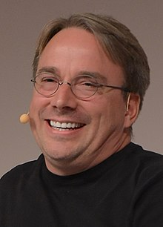

- Who is Tux?
Tux is the official mascot of the Linux Kernel and, by extension, the linux operating System. It is a penguin character that was chosen as the mascot by Linus Torvalds. The name “tux” is derived from “Tuxedo”, reflecting the formal appearance of the penguin




- Make a short review of the main Linux distributions (Debian, Mint, Ubuntu, Solus. Fedora, openSUSE, Mandriva, Gentoo, Sabayon, CentOS, ...) [Answer – Logos, Description, History, URL].


Debian:

Description: Debian is a stable and versatile Linux distribution known for its commitment to free software principles. It uses the APT package management system and features multiple desktop environments.
History: Debian was founded in 1993 by Ian Murdock. It has since grown into one of the largest and most influential Linux distributions, serving as the foundation for many other distributions.

URL: https://www.debian.org/

Linux Mint:


Description: Linux Mint is a user-friendly distribution based on Ubuntu and Debian. It aims to provide a complete out-of-the-box experience by including proprietary software, codecs, and multimedia support.
History: Linux Mint was first released in 2006 by Clement Lefebvre. It has since gained popularity for its ease of use and focus on desktop aesthetics.
URL: https://www.linuxmint.com/

Ubuntu:


Description: Ubuntu is one of the most popular Linux distributions, known for its simplicity, ease of use, and strong community support. It offers a wide range of flavors for different use cases and desktop environments.
History: Ubuntu was created in 2004 by Mark Shuttleworth and the Ubuntu community. It is based on Debian and follows a six-month release cycle.
URL: https://ubuntu.com/

Solus:



Description: Solus is an independent Linux distribution known for its desktop-focused approach and curated selection of software. It uses its own package manager called "eopkg" and features the Budgie desktop environment.
History: Solus was initially released in 2015 by Ikey Doherty. It has since gained popularity for its user-friendly design and attention to detail.
URL: https://getsol.us/

Fedora:


Description:Fedora is a community-driven Linux distribution sponsored by Red Hat. It focuses on innovation, integration of new technologies, and providing a platform for developers.
History: Fedora was launched in 2003 as the "Fedora Project" by Red Hat. It serves as the upstream source for Red Hat Enterprise Linux (RHEL).
URL: https://getfedora.org/

openSUSE:


Description: openSUSE is a stable and easy-to-use Linux distribution known for its YaST configuration tool and the choice between the rolling release "Tumbleweed" and the regular release "Leap."
History: originated from the German SUSE Linux distribution, which was first released in 1994. It became an independent project in 2005 and has since been developed by the openSUSE community.
URL: https://www.opensuse.org/

Gentoo:
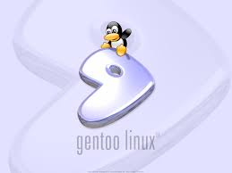

Description: is a source-based Linux distribution known for its flexibility, customization options, and performance optimization through compiling source code on the user's machine.
History: was created in 2000 by Daniel Robbins. It follows a "rolling release" model and emphasizes user control and choice.

URL: https://www.gentoo.org/

Sabayon:


Description: is a Gentoo-based Linux distribution that aims to provide a complete and easy-to-use desktop experience out of the box. It features a rolling release model and includes a wide range of pre-installed software.
History: was founded in 2005 by Fabio Erculiani. It offers multiple desktop environments and targets both desktop and server users.
URL: https://www.sabayon.org/

CentOS:


Description: is a community-driven Linux distribution known for its stability, long-term support, and binary compatibility with Red Hat Enterprise Linux (RHEL). It is often used for servers and enterprise environments.
History: was released in 2004 as a free alternative to RHEL. It is maintained by the CentOS Project and receives updates and security patches from the community.

URL: https://www.centos.org/

- What is a Linux distribution?
Is a complete operating system based on the linux kernel along with additional software packages and utilities. While the Linux kernel forms the core of the operating system, a distribution includes a collection of software such as libraries, compilers, desktop environments, package managers and applications that make the system usable for end-users

- Explain the four freedoms that software released under the GPL must comply with.
Freedom 0: The Freedom to Run the Program for Any Purpose
Users are free to run the software for any purpose, whether it's for personal, commercial, educational, or any other use. There are no restrictions on how the software can be utilized.

Freedom 1: The Freedom to Study How the Program Works and Adapt It to Your Needs
Users have the freedom to access the source code of the software, study how it functions, and modify it to suit their needs. This allows users to understand how the software works, make improvements, fix bugs, or customize it for specific requirements.

Freedom 2: The Freedom to Redistribute Copies
Users are free to redistribute copies of the software to others, either as-is or with modifications. This enables sharing and collaboration within the community, allowing others to benefit from the software and contribute to its development.

Freedom 3: The Freedom to Distribute Modified Versions
Users have the freedom to distribute modified versions of the software. This means that users can make changes to the software, distribute the modified versions to others, and contribute their improvements back to the community. This fosters innovation, encourages collaboration, and ensures that improvements are shared with everyone.

- Complete de the table with the information about the main Ubuntu distros in the last years:
Version | Code Name | Release | End of life
Ubuntu 24.04 LTS | Noble Numbat | April 25, 2024 | April 2034
Ubuntu 23.10 | Mantic Minotaur | October 12, 2023 | July 2024
Ubuntu 23.04 | Lunar Lobster | April 20, 2023 | January 2024
Ubuntu 22.10 | Kinetic Kudu | October 20, 2022 | July 2023
Ubuntu 22.04 LTS | [Jammy Jellyfish]. | [April 21, 2022]. | [April 2034].
Ubuntu 21.10 | [Impish Indri]. | [October 14, 2021]. | [July 14, 2022].
Ubuntu 21.04 | [Hirsute Hippo]. | [April 22, 2021]. | [January 20,2022].
Ubuntu 20.10 | [Groovy Gorilla]. | [October 22, 2020]. | [July 22, 2021].
Ubuntu 20.04 LTS | [Focal Fossa]. | [April 23, 2020]. | [April 2032].
Ubuntu 19.10 | [Eoan Ermine]. | [October 17, 2019]. | [July 17, 2020].
Ubuntu 19.04 | [Disco Dingo]. | [April 18, 2019]. | [January 23, 2020].
Ubuntu 18.10 | [Cosmic Cuttlefish]. | [October 18, 2018]. | [July 18, 2019].
Ubuntu 18.04 LTS | [Bionic Beaver]. | [April 26, 2018]. | [April 2030].
Ubuntu 17.10 | [Artful Aardvark]. | [October 19, 2017]. | [July 19 2018].
Ubuntu 17.04 | [Zesty Zapus]. | [April 13, 2017]. | [January 13, 2018].
Ubuntu 16.10 | [Yakkety Yak]. | [October 13, 2016]. | [July 20, 2017].
Ubuntu 16.04 LTS | [Xenial Xerus]. | [April 21, 2016]. | [April 2028].

Installing Linux
- Take a screenshot of the download web page and the ISO that you will use for the installation.
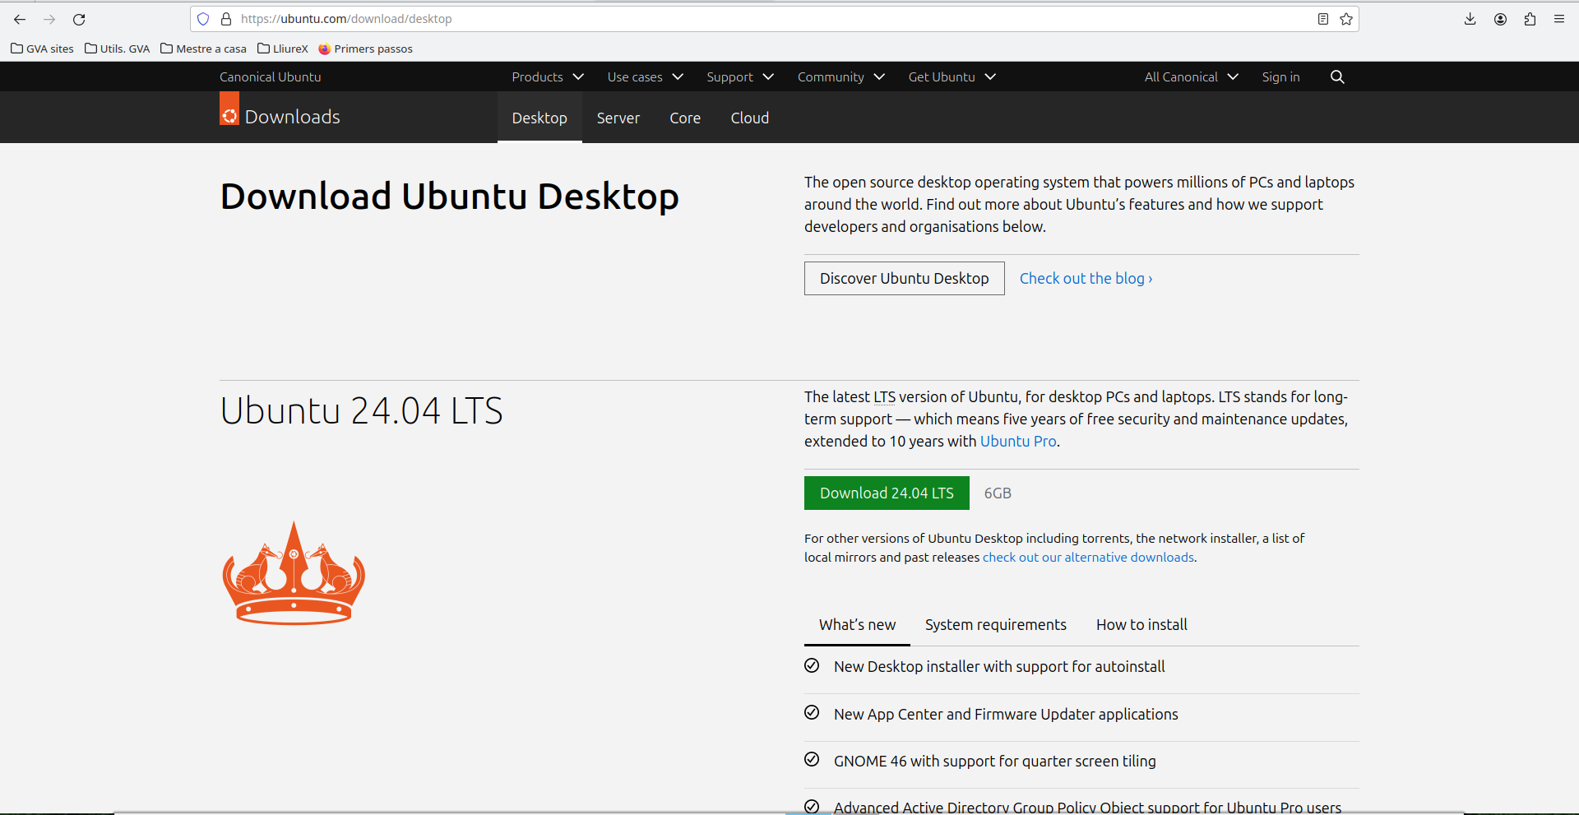
- Download ISO image of an Ubuntu Desktop LTS version from the official website (https://ubuntu.com/download/desktop). [ Figure from Ubuntu official website and ISO image of installation].
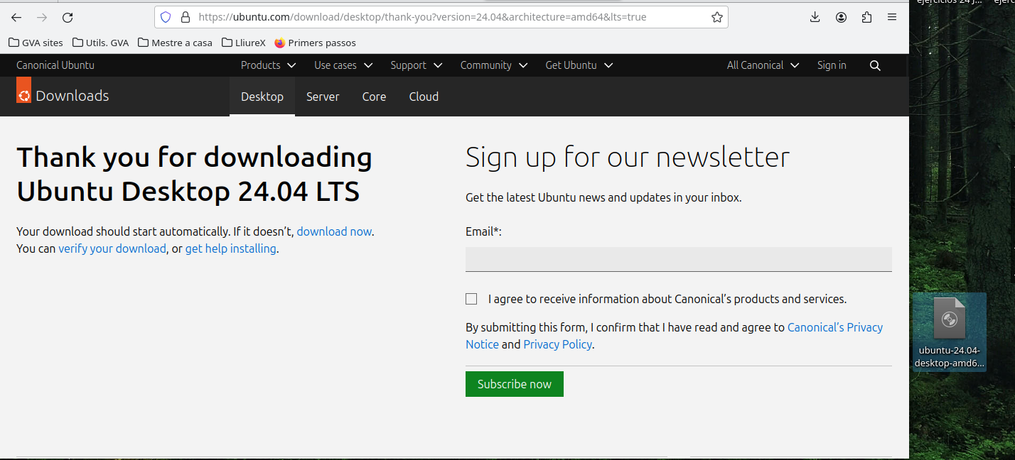

- Create an Ubuntu XX.04-Desktop LTS (UbuntuXX-<codId>) virtual machine (minimum disk space 42 GiB), with a Bridged Adapter-like network interface.
If you do not understand the meaning of the yellow text -<codId> please read the delivery rules again and ask the teacher.
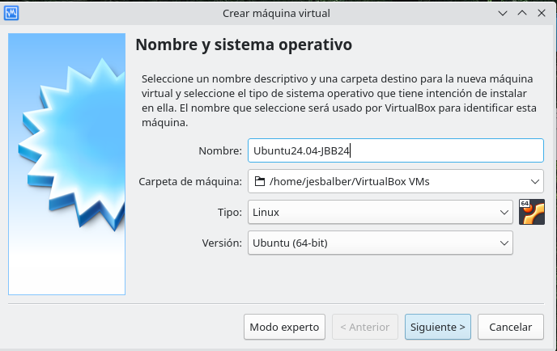

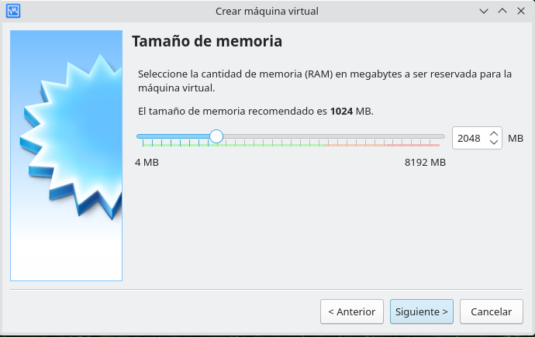

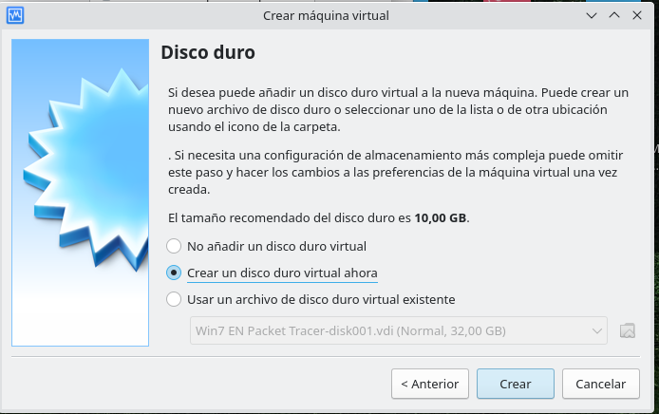

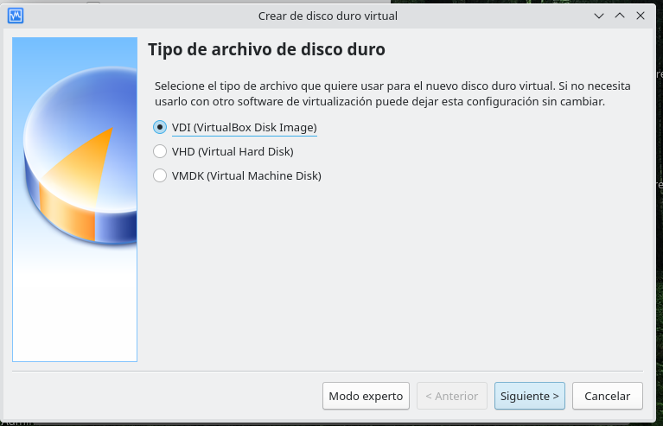

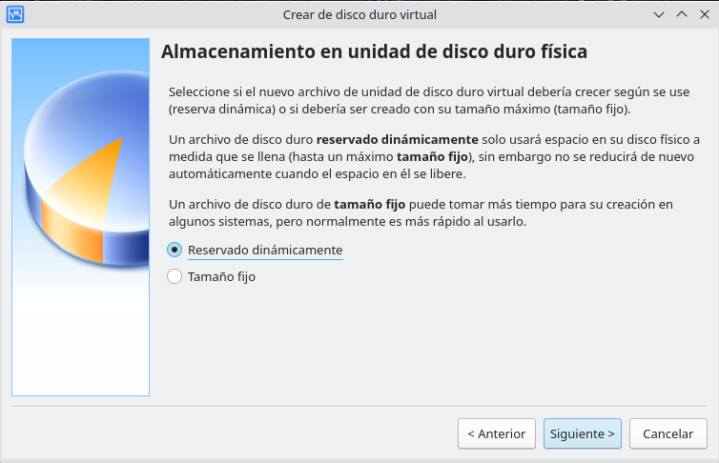

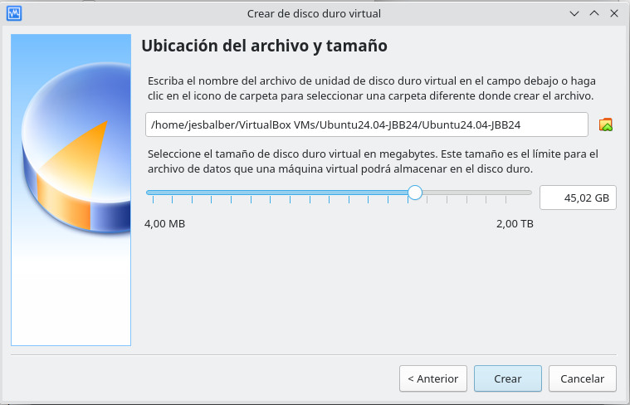

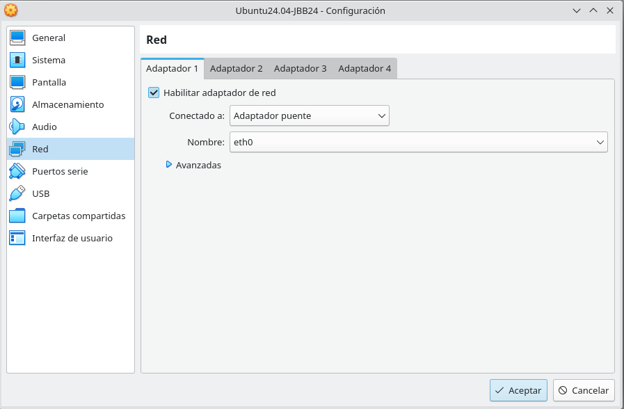

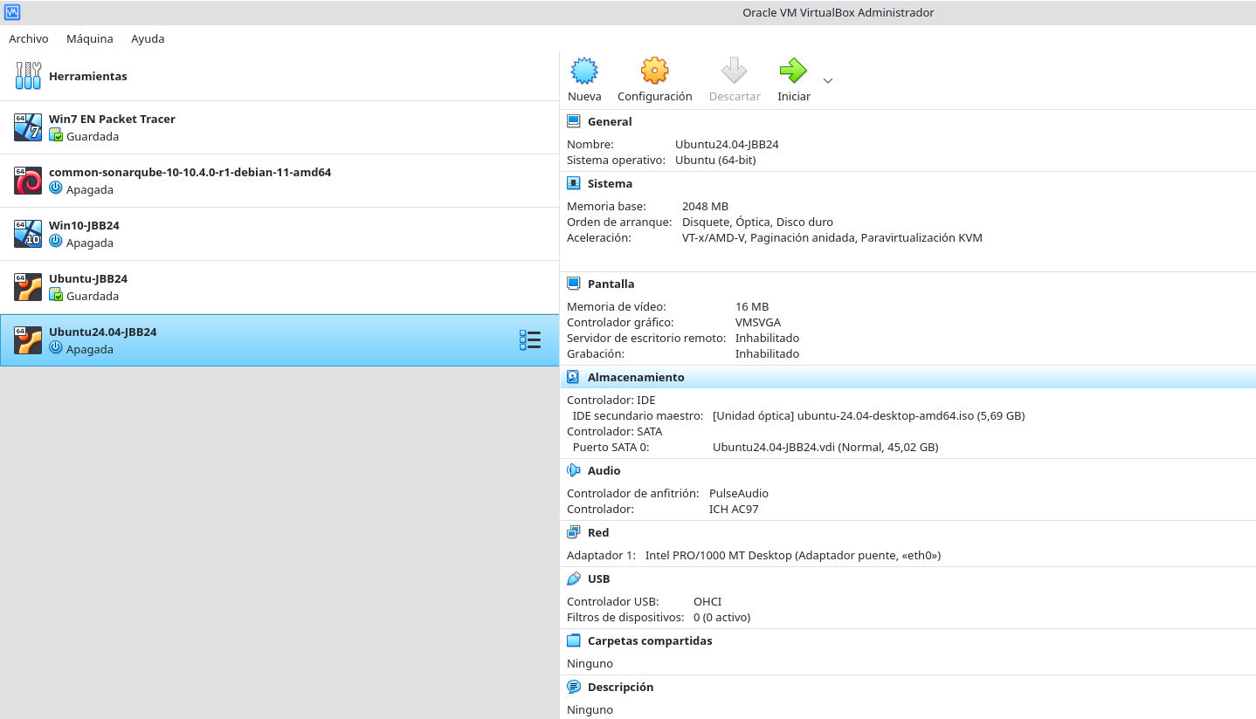

- Capture the screen of the setup process:” GNU GRUB version x.yy”.
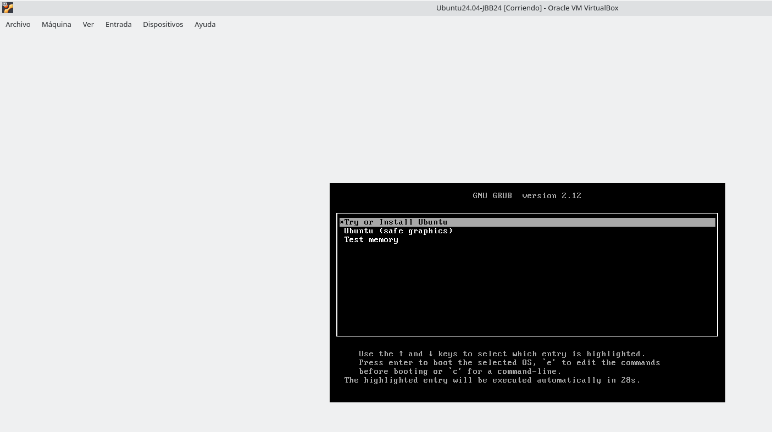
- Capture screen Welcome install – Language: English - Install Ubuntu.

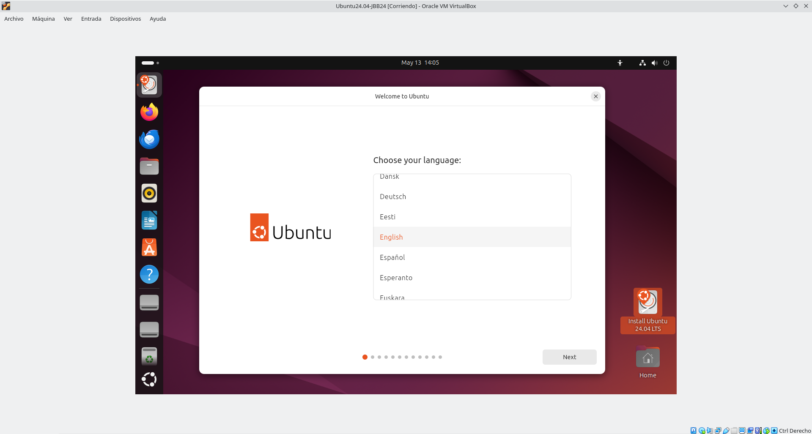

- Choose your keyboard layout: Spanish.
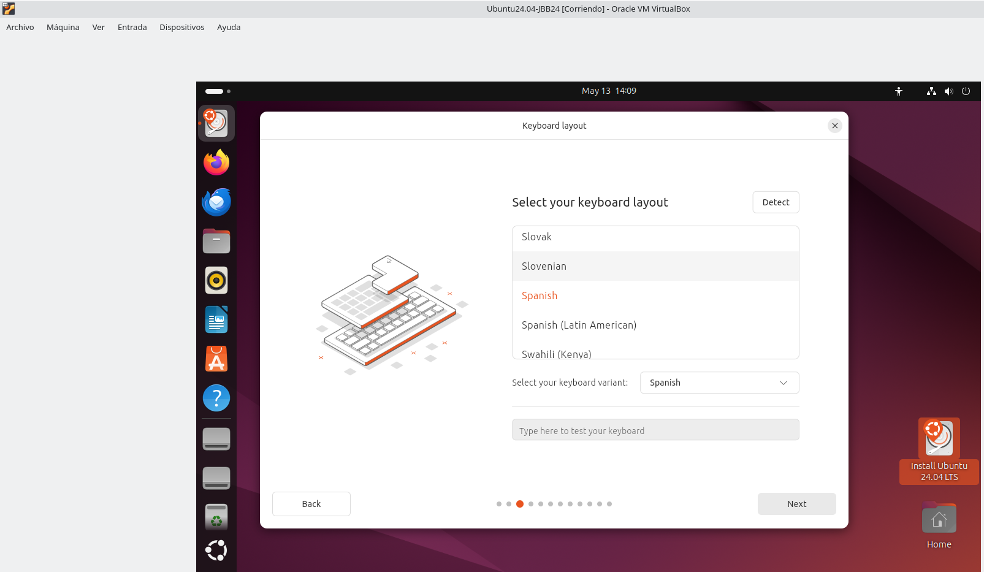
- Capture screen Updates and other software. Normal installation.
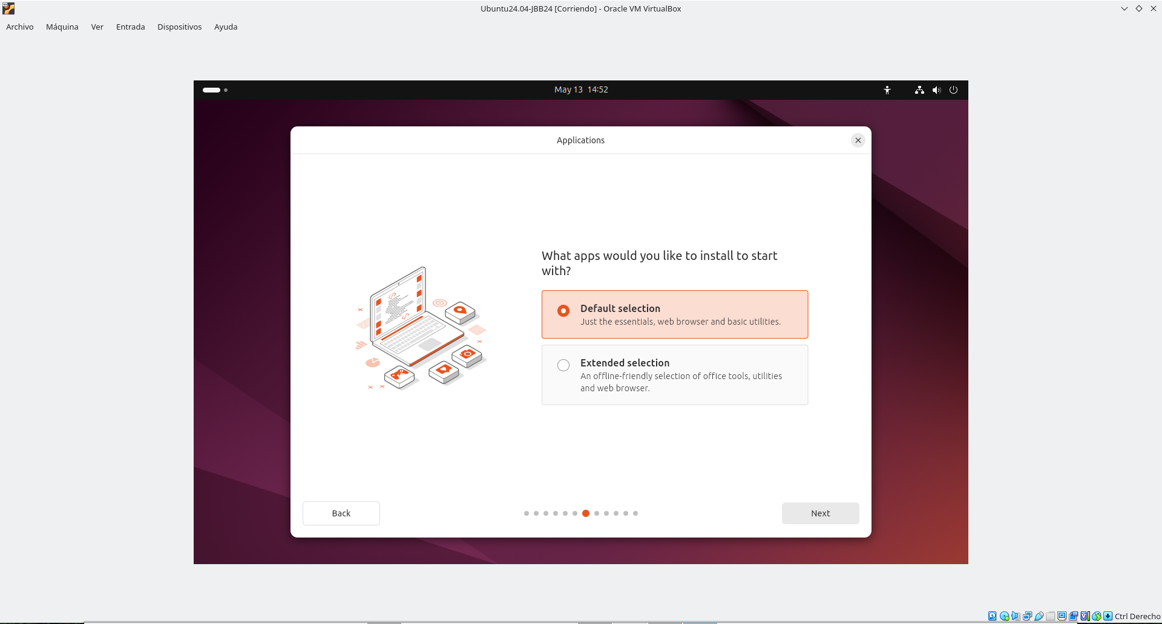

- Capture screen Installation type: Erase disk and install Ubuntu.
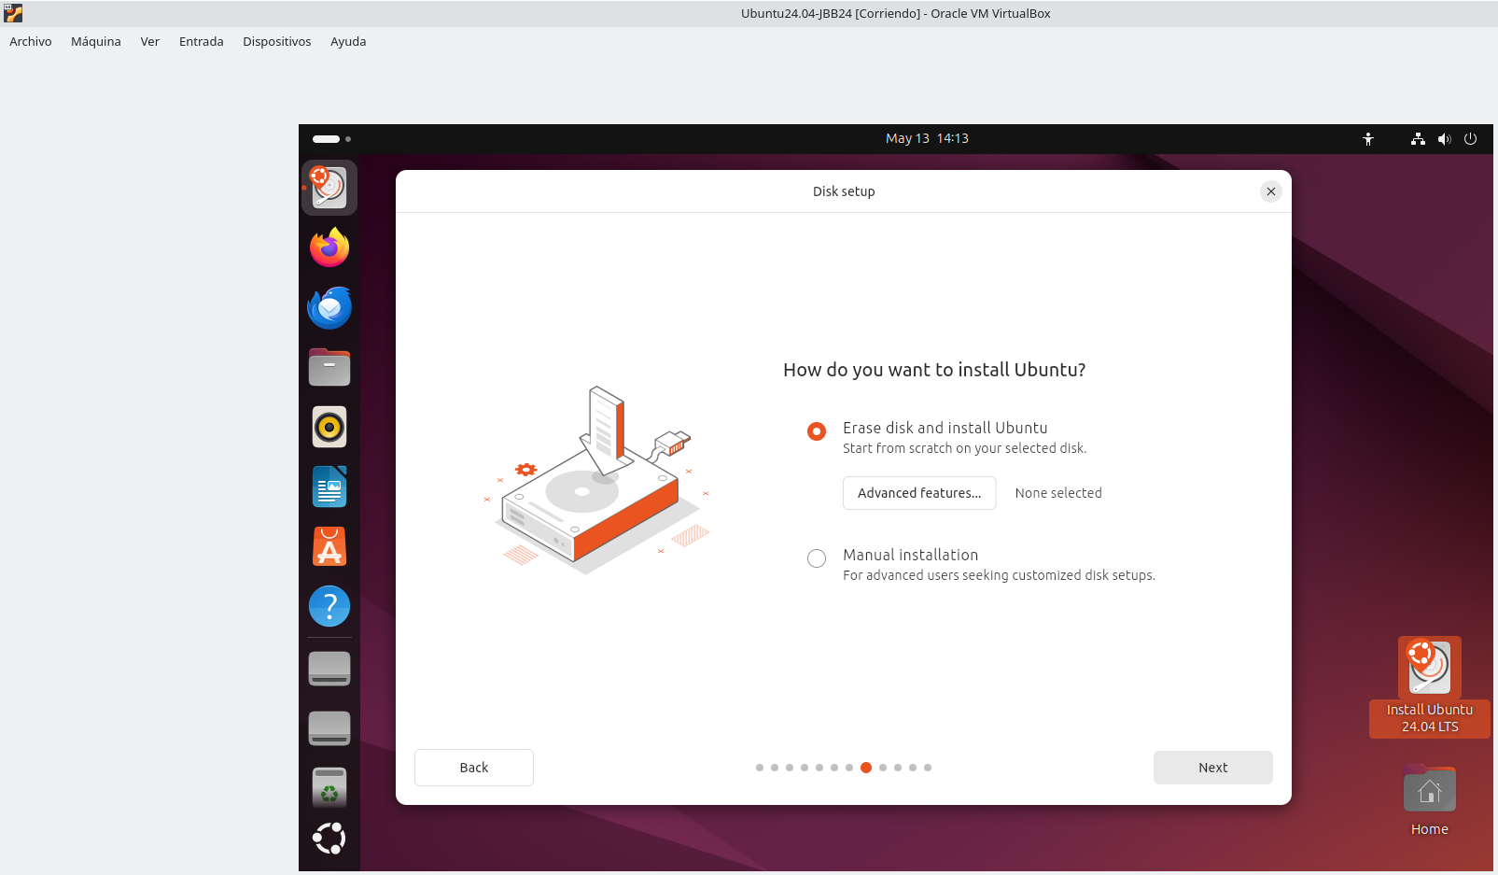
- Capture screen Write the changes and to disks?

This window don’t appear

- Capture screen Install – Where are you? Madrid. [Screenshot].
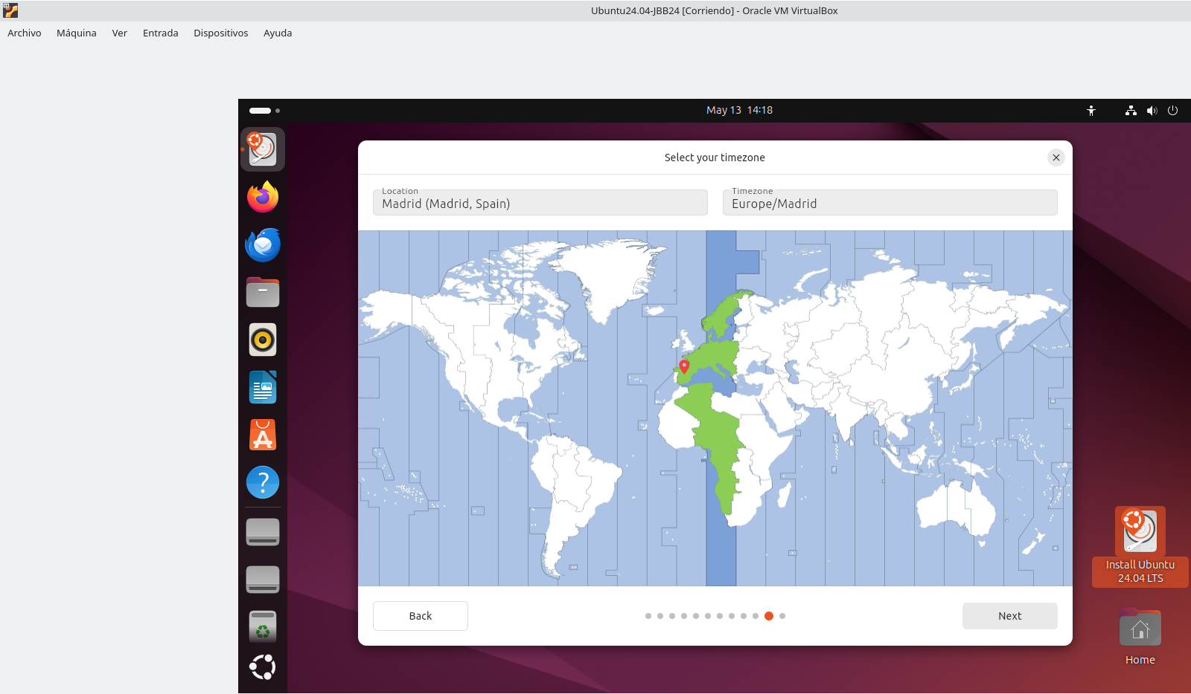

- Capture screen Who are you? Create a user account with your name.
- Your name: Full name – Name and surnames.
- Your computer’s name: Surname-<codId>.
- Pickup a username: Student’s first name.
- Password: 12345678Aa ✓
- Require my password to log in.
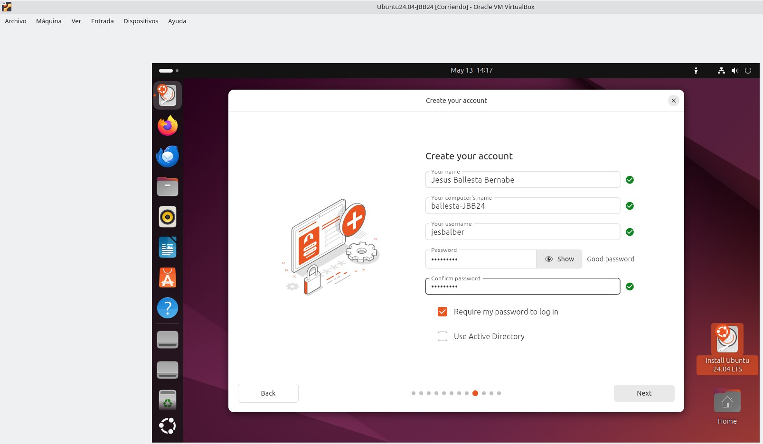

- Capture screen Install – Welcome to Ubuntu.
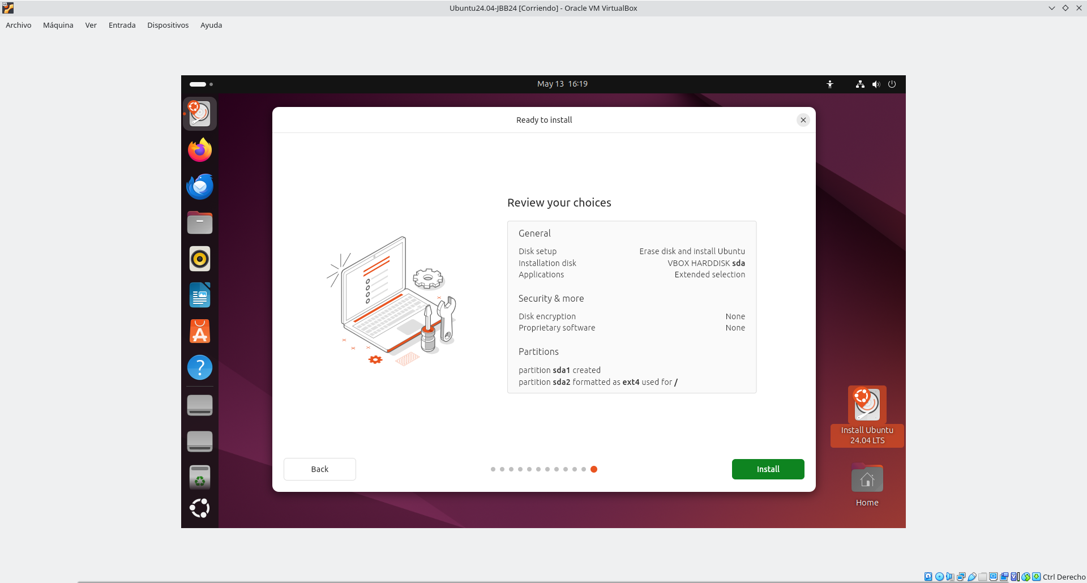
- Capture screen Install – Find even more software …
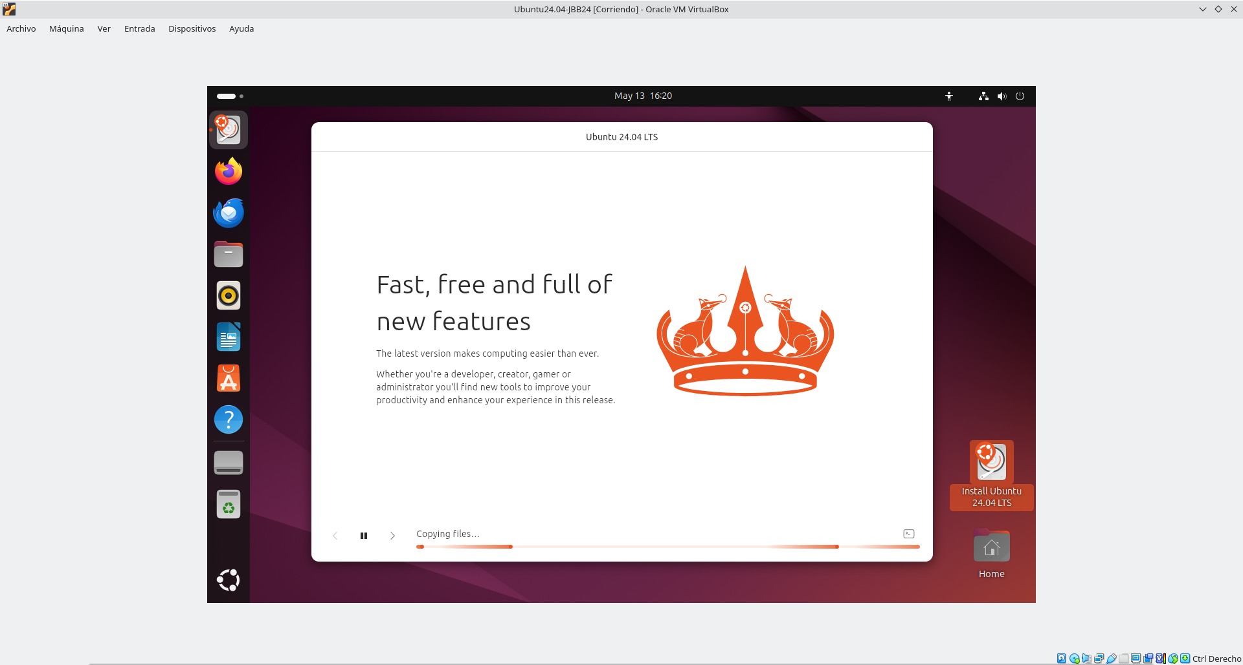

- Capture screen “Installation complete. You need to restart your computer to use new installation”. Restart Now.
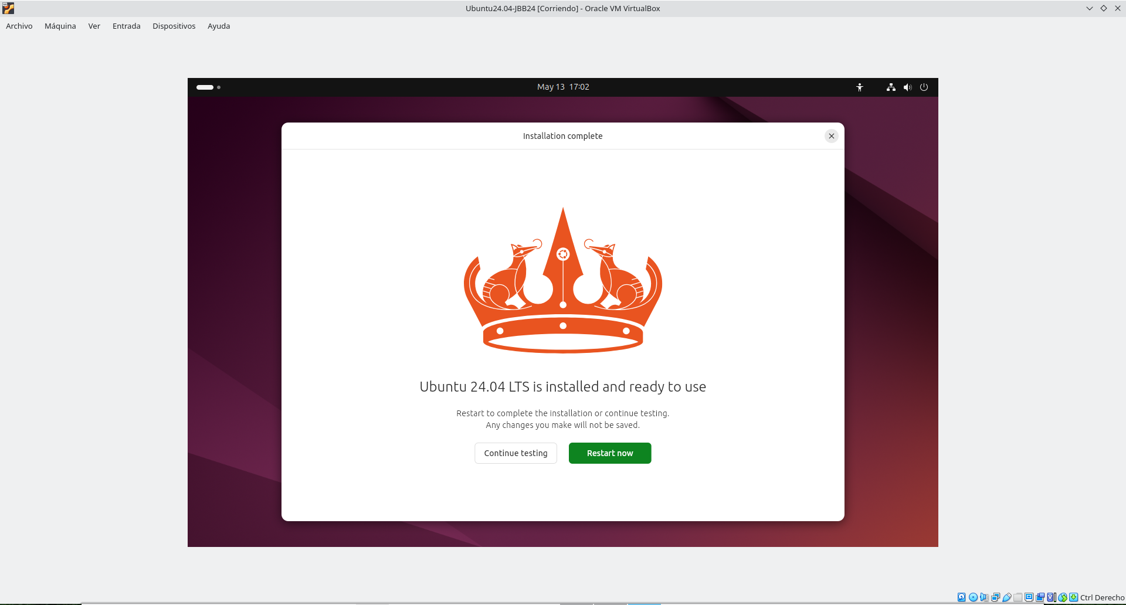

- Capture screen Please remove installation medium and press ENTER.
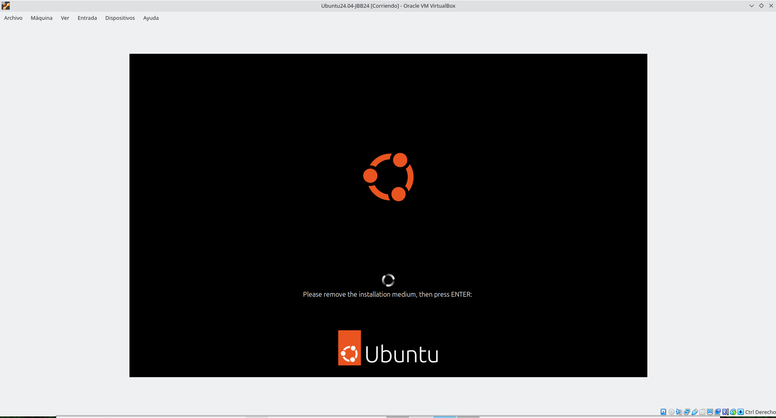

First steps
- Capture the login screen.
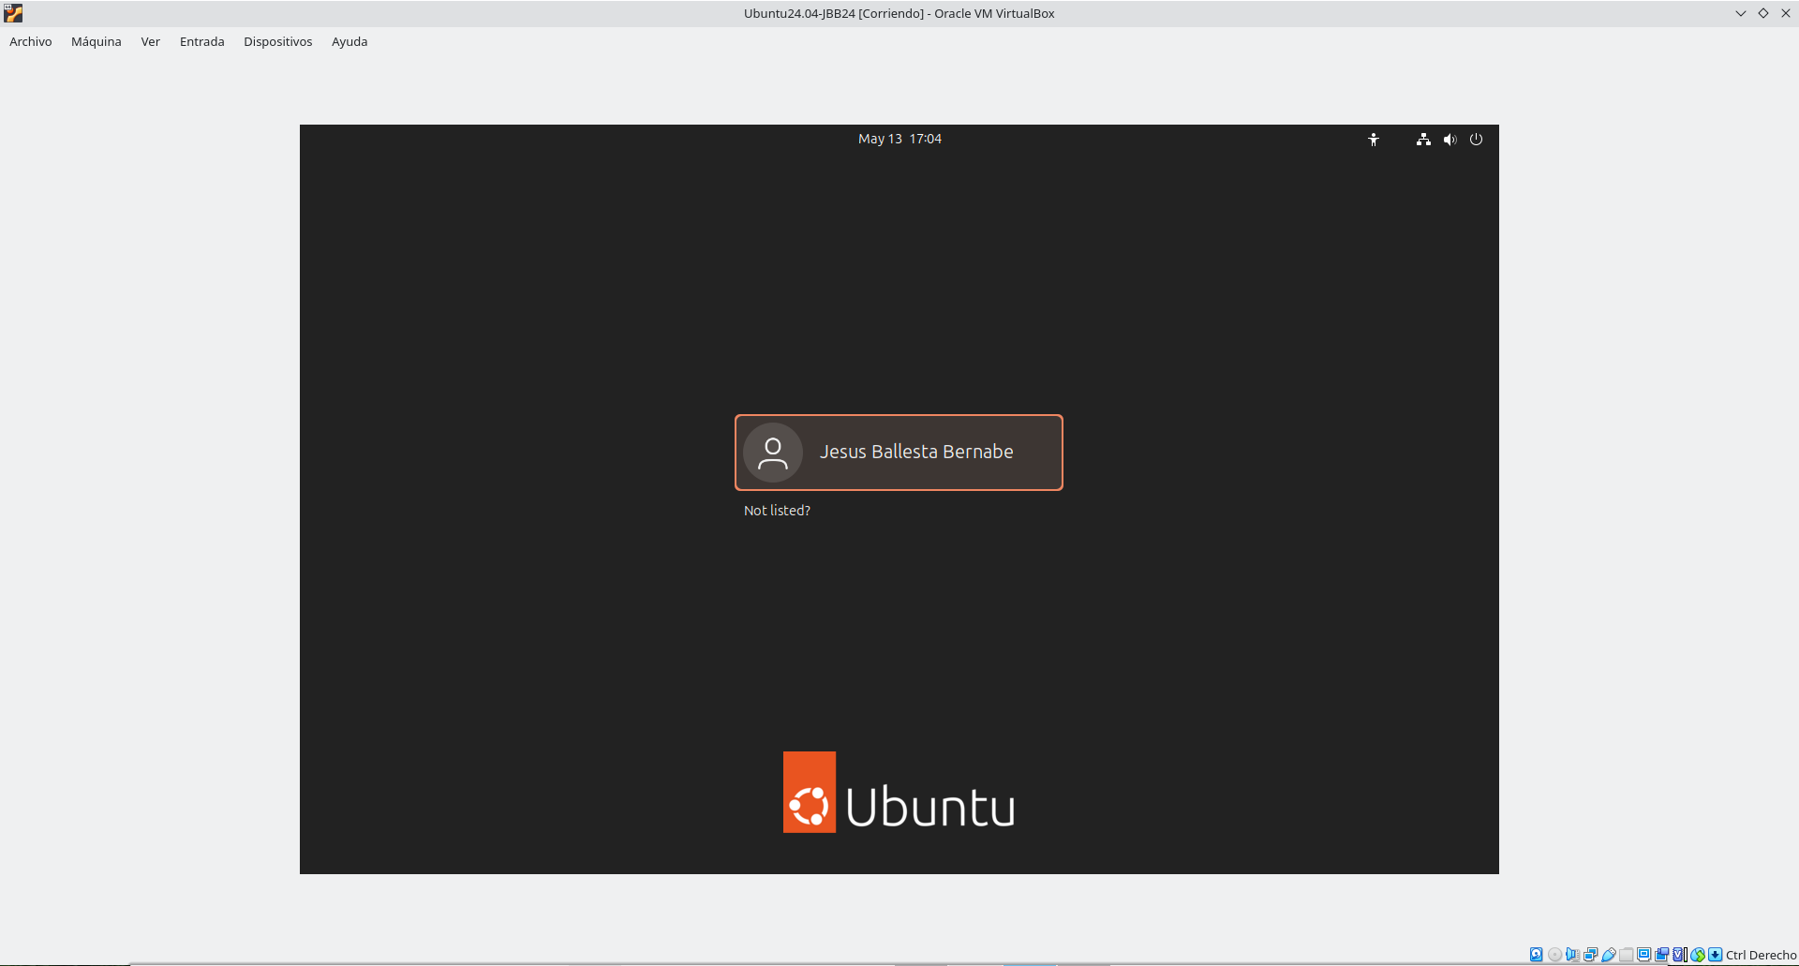
- Sign in with the user account that you created during the installation process (student first name / 12345678Aa).
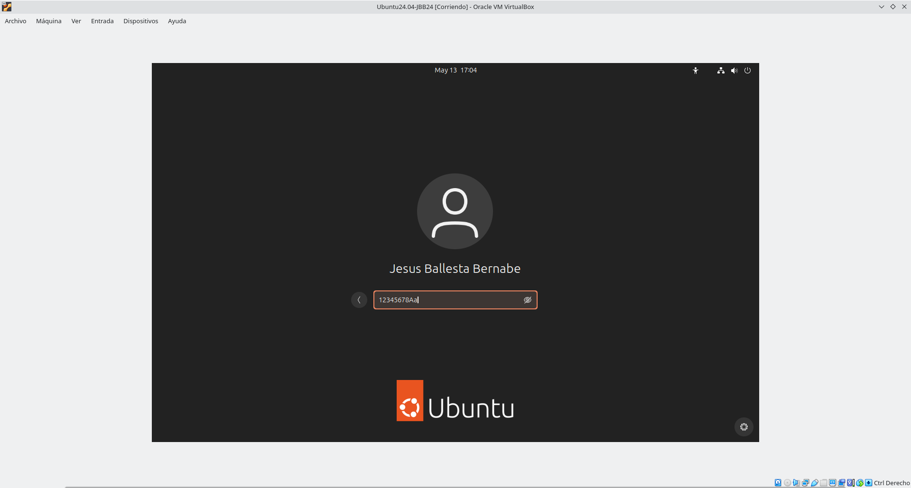

- Open a Terminal and run command id.
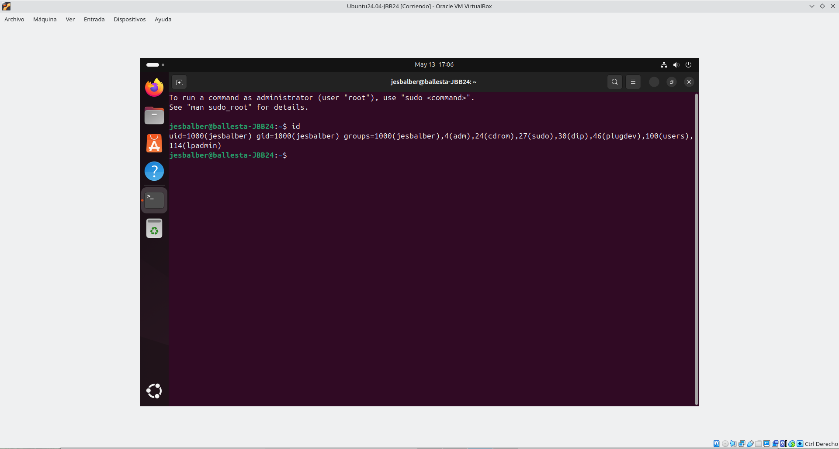
- Capture screen Install – Welcome to Ubuntu – Enable Ubuntu Pro. Skip for now …
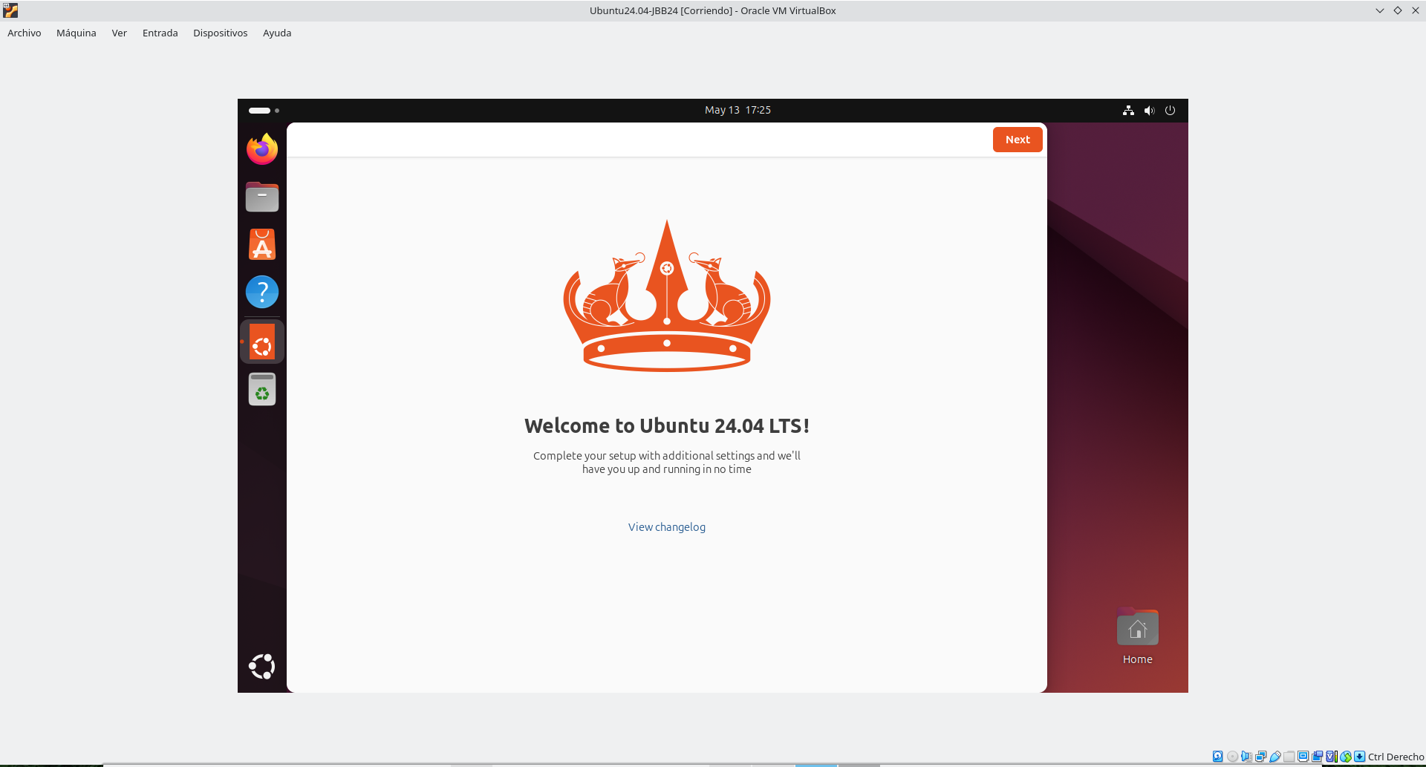

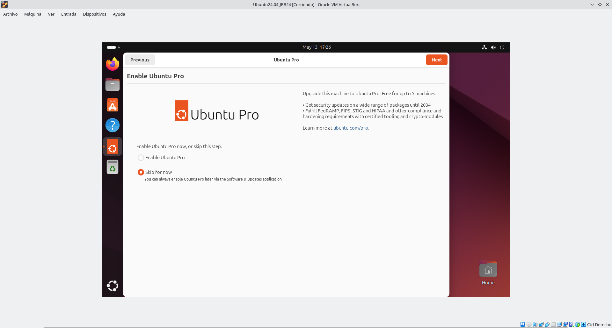
- Capture screen Help improve Ubuntu > No, I don’t send system info.

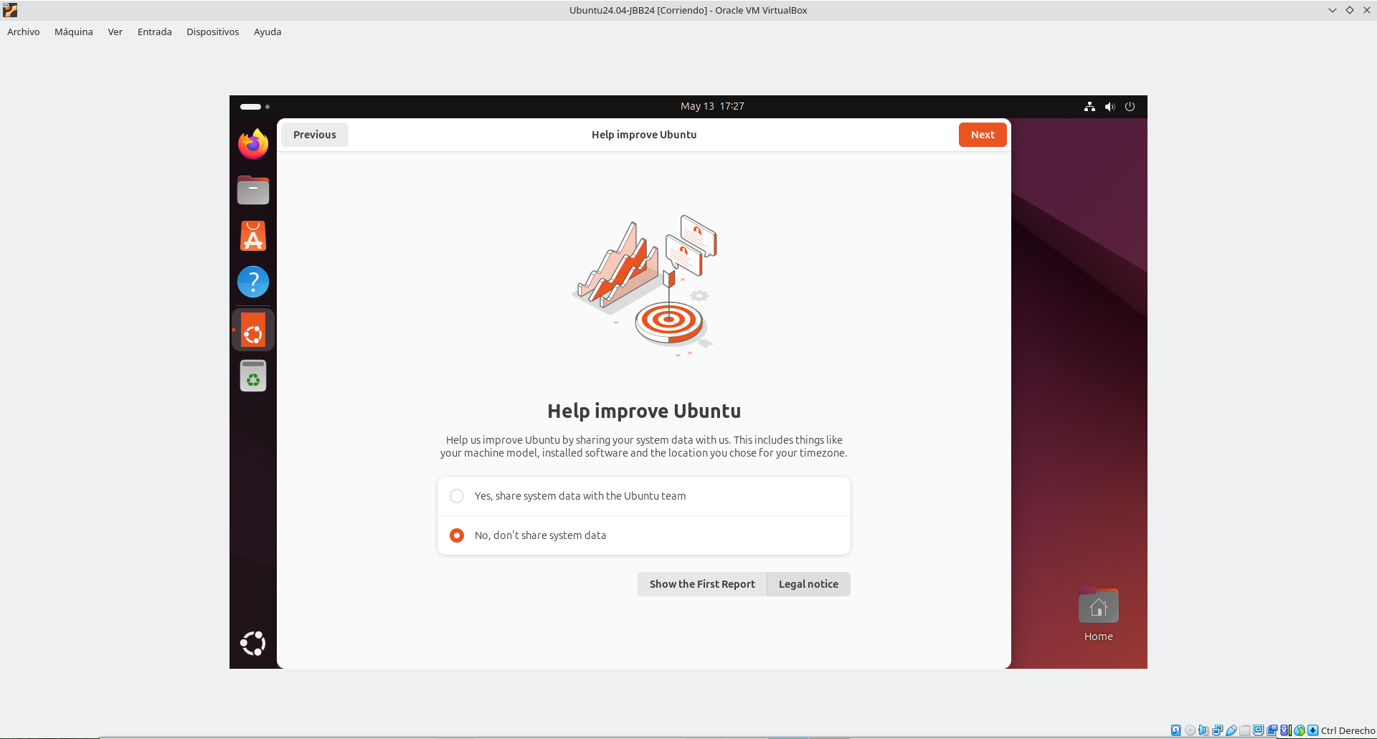

- Capture screen Welcome to Ubuntu – Location services > On.
This windows don’t appear
- Capture screen You’re ready to go! [Screenshot]. Click Done button.
This windows don’t appear
- Capture screen of the Ubuntu Desktop.
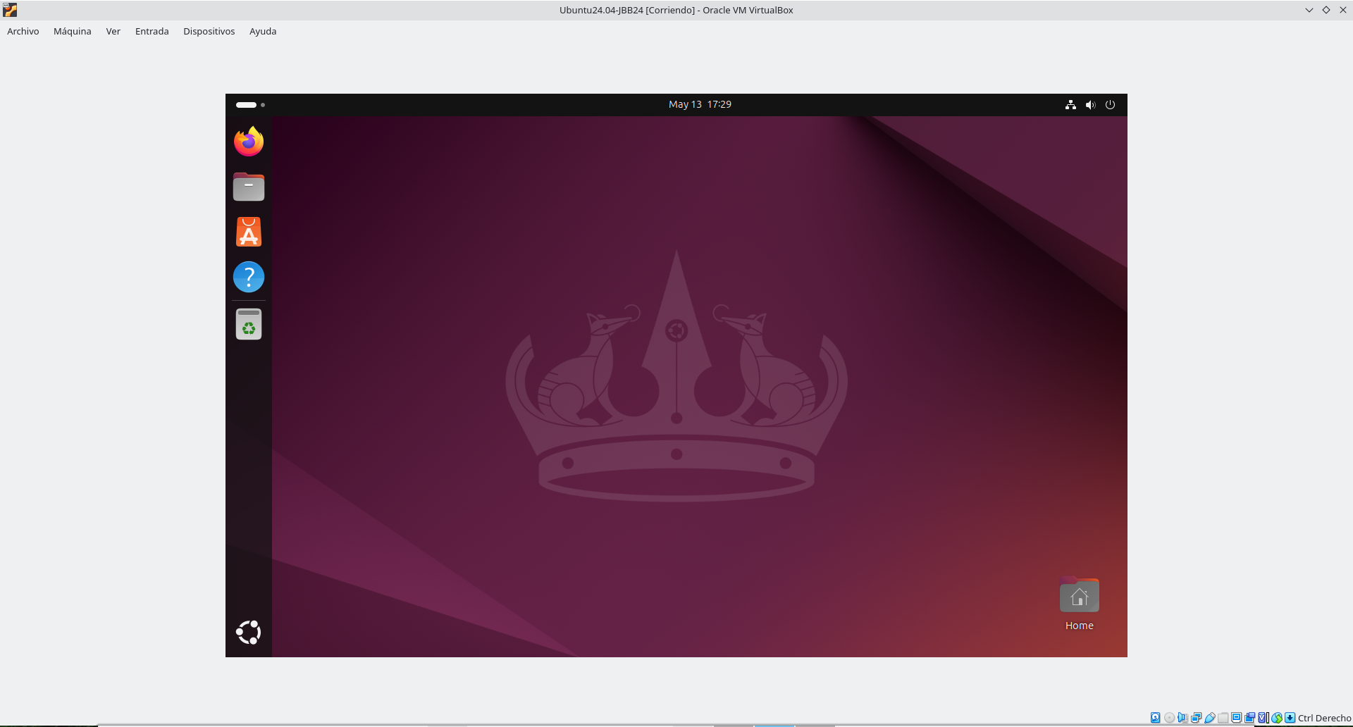

- Change Desktop Background. Capture screen.
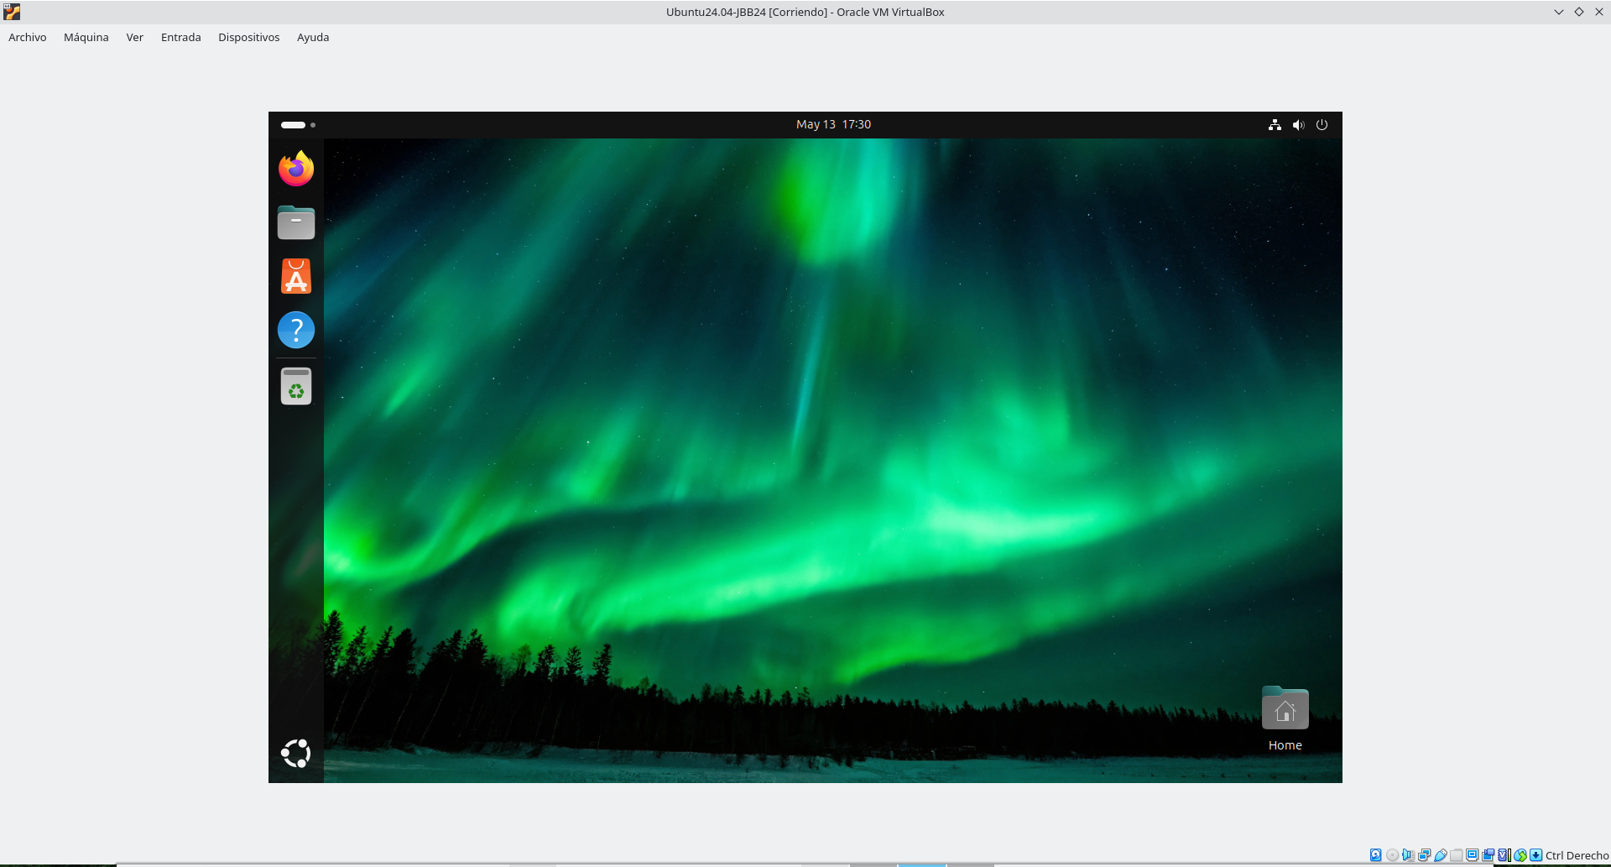
- Use the application Tweaks to change Desktop Background.

- Use the application Tweaks to show clock (weekday, date and seconds) on Top Bar. [Screenshots].
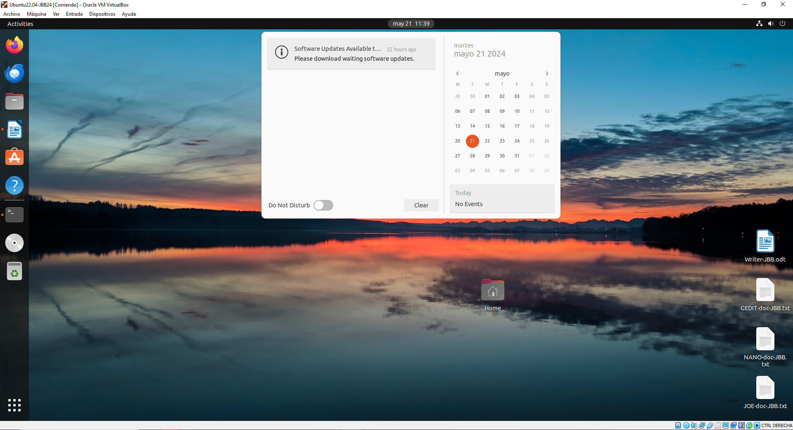

- Sign in, and on the shell run the commands: Is (display the contents of a directory), cd (change directory), cat (view the contents of a file), more (view the contents of a file with pause), clear (clear screen) for get to know your directory structure.
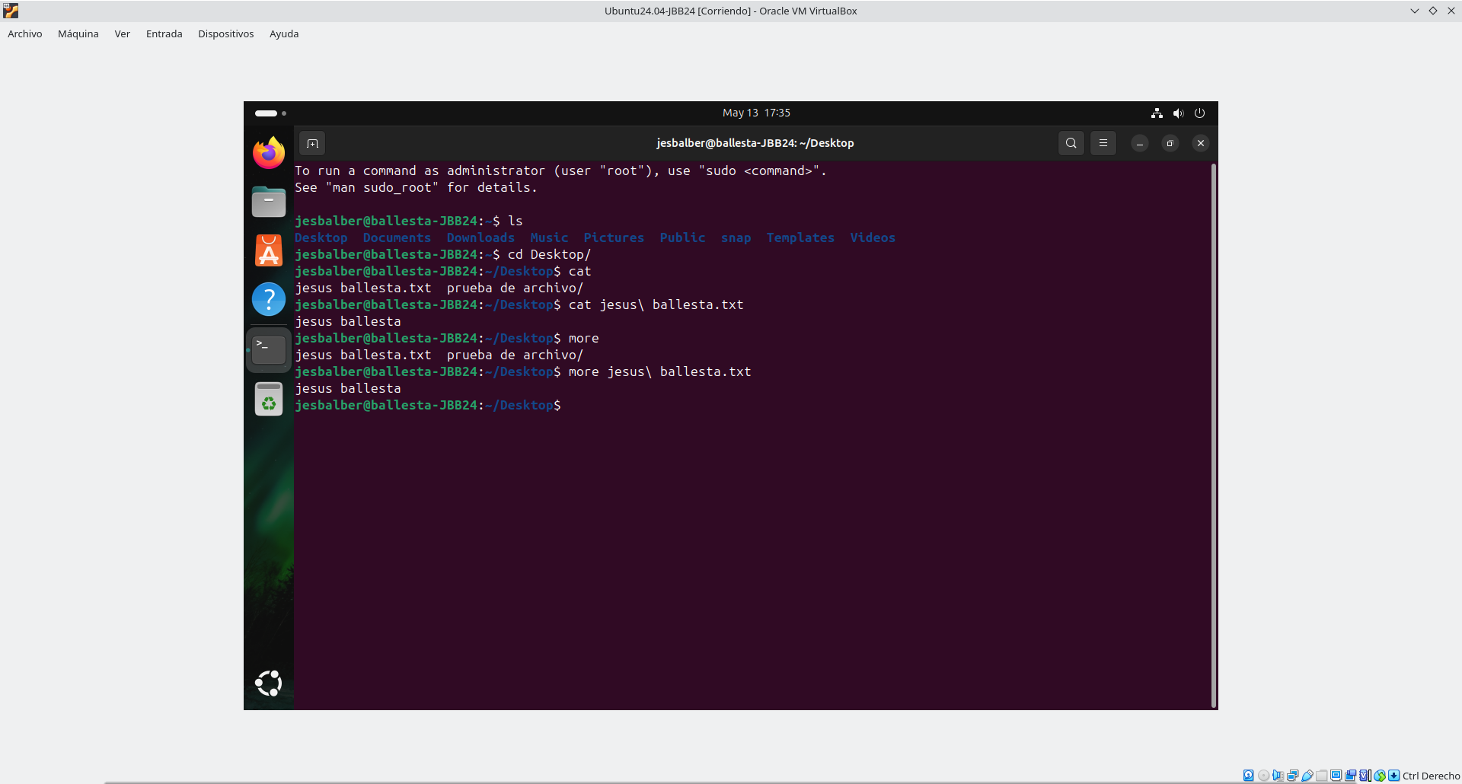
- Display content of the directories: / (root), /etc, /tmp, /proc, and /home, and of configuration files: /etc/passwd, /etc/group, /etc/hostname, /etc/hosts, /etc/fstab, /etc/network/interfaces and files in /etc/netplan.
/root:
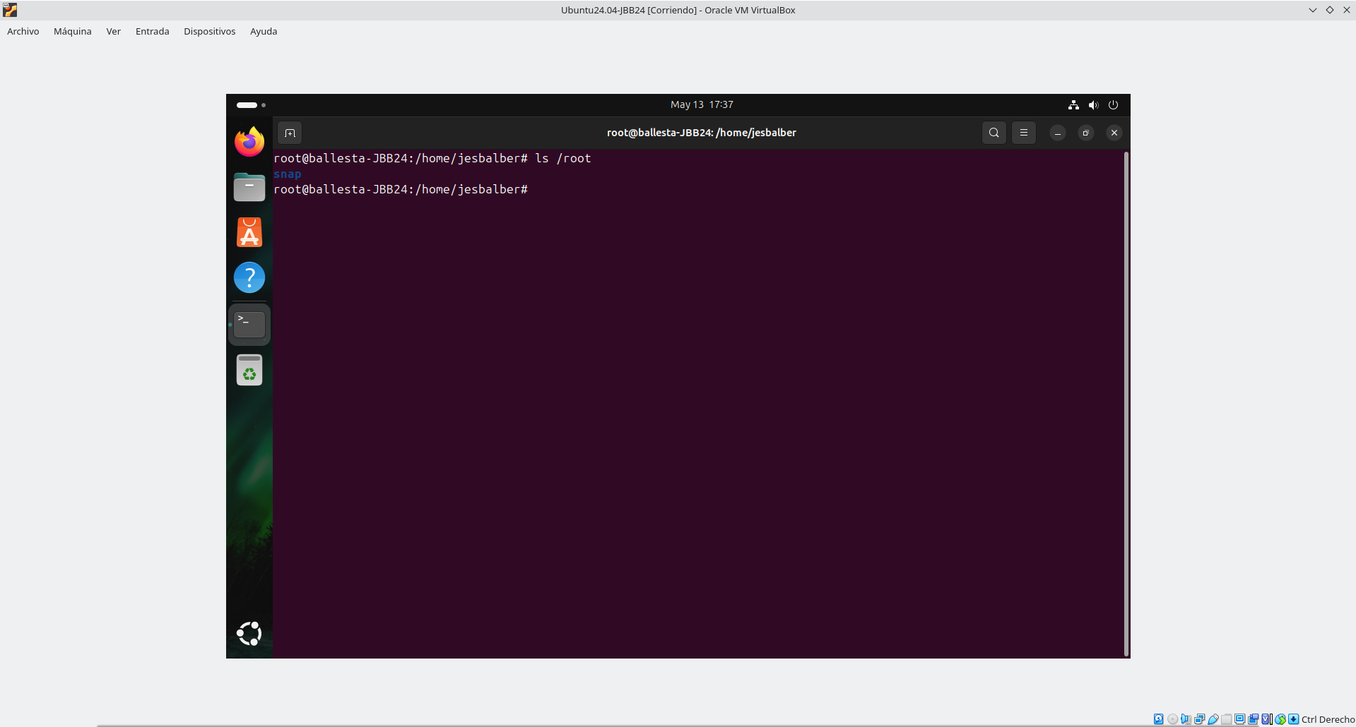
/etc:
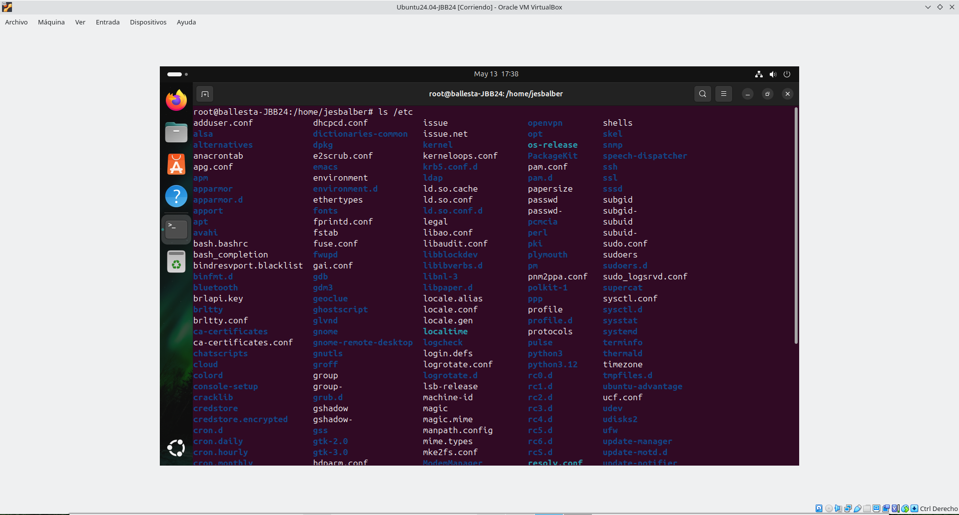

/tmp:
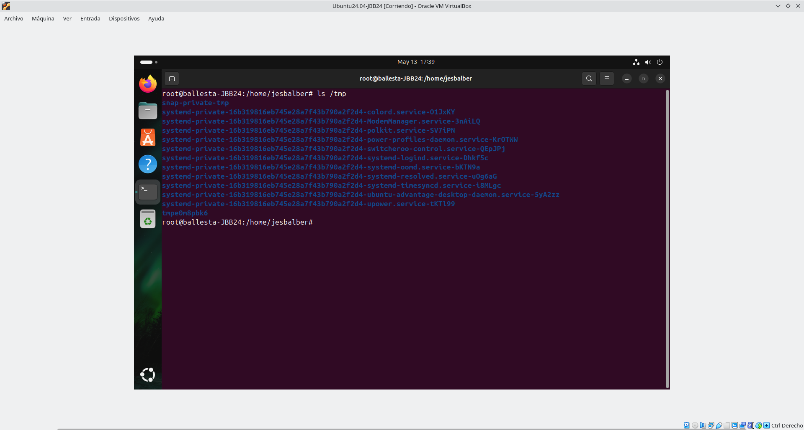
/proc:
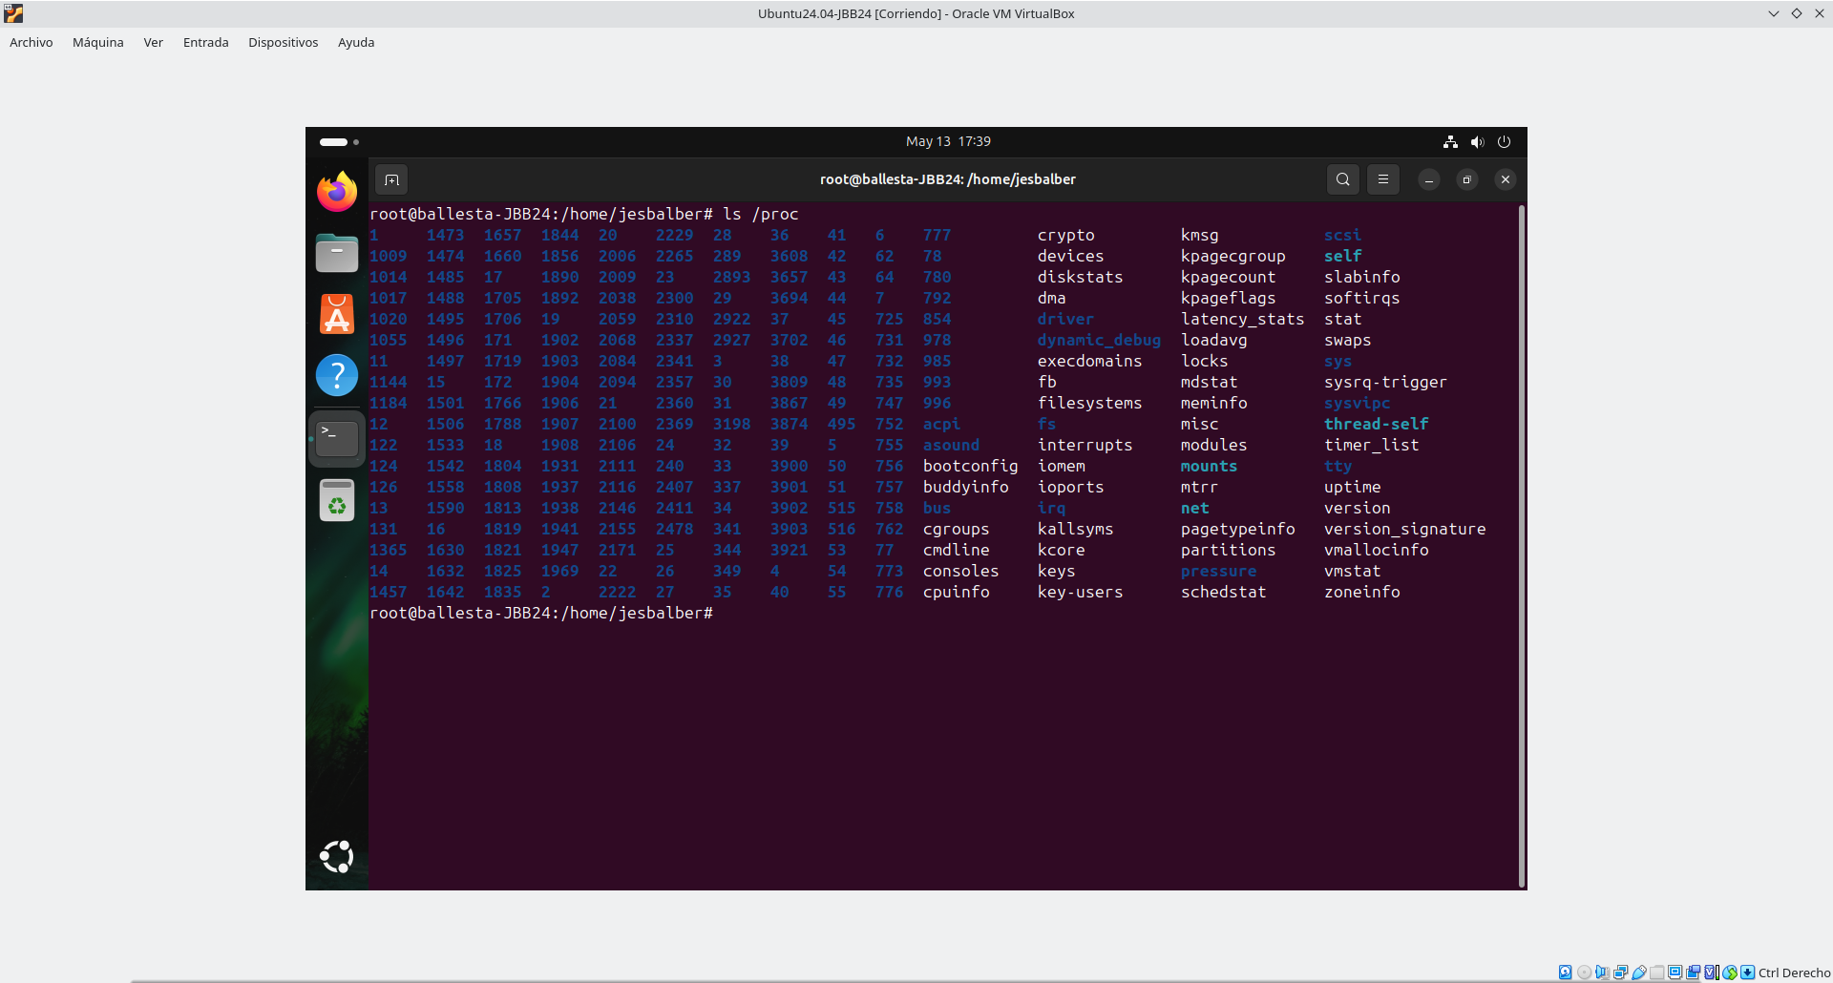

/home:
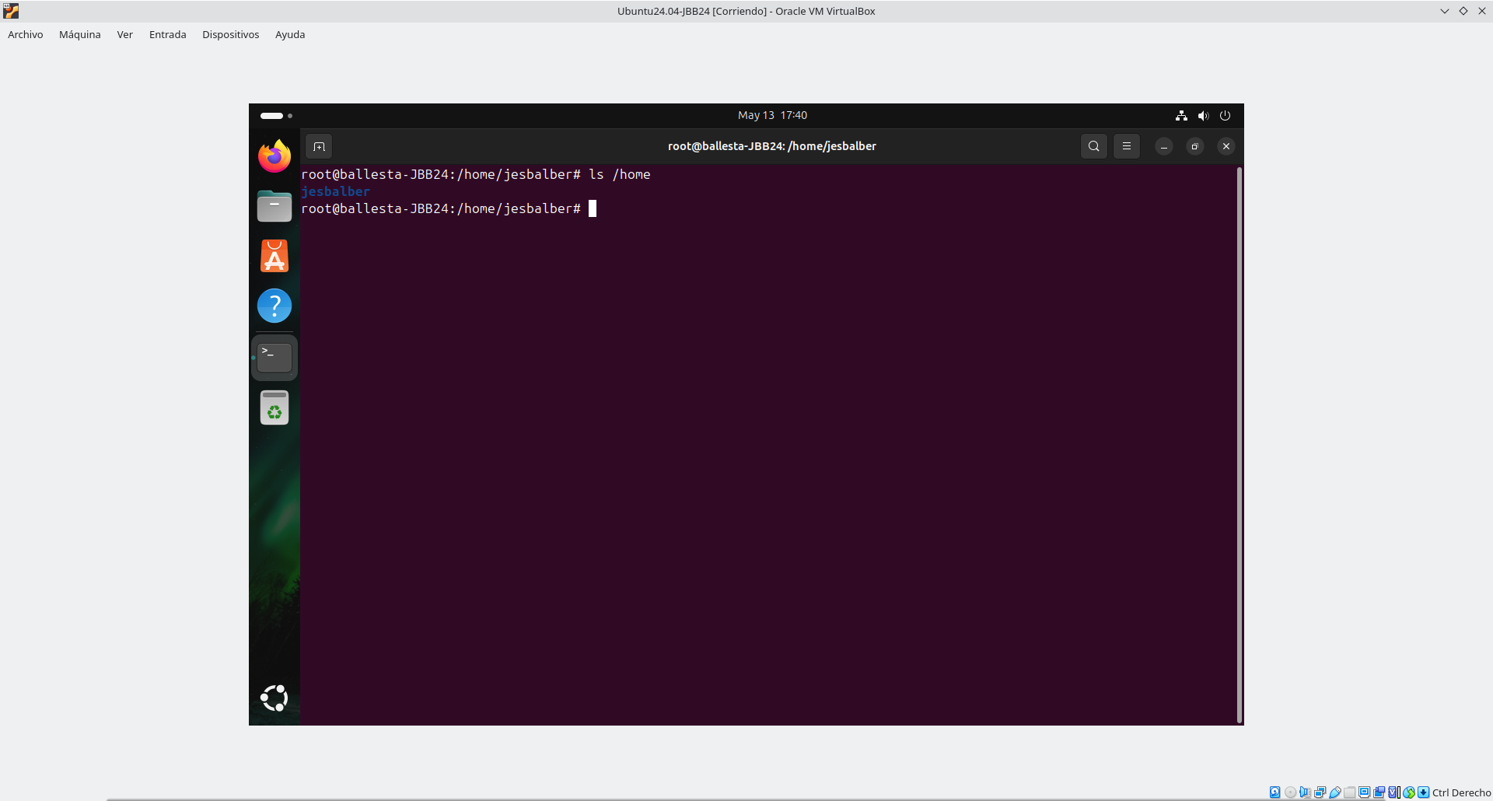
/etc/passwd
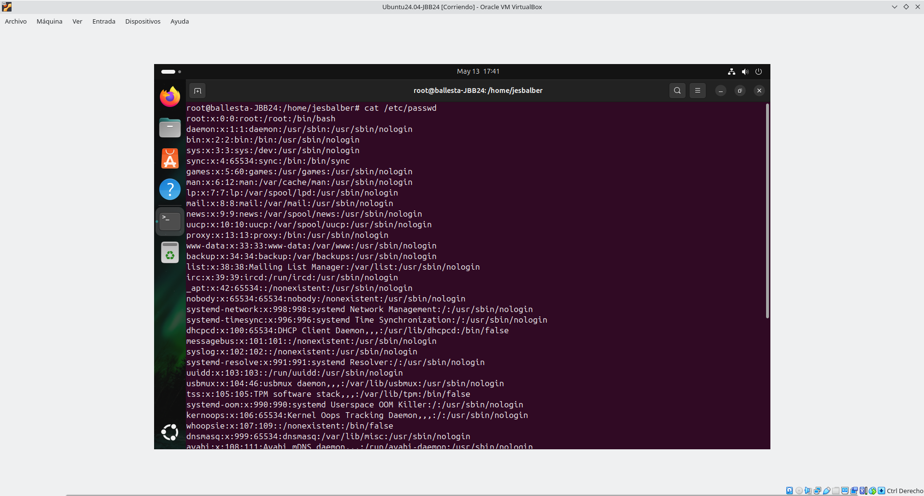

/etc/group:
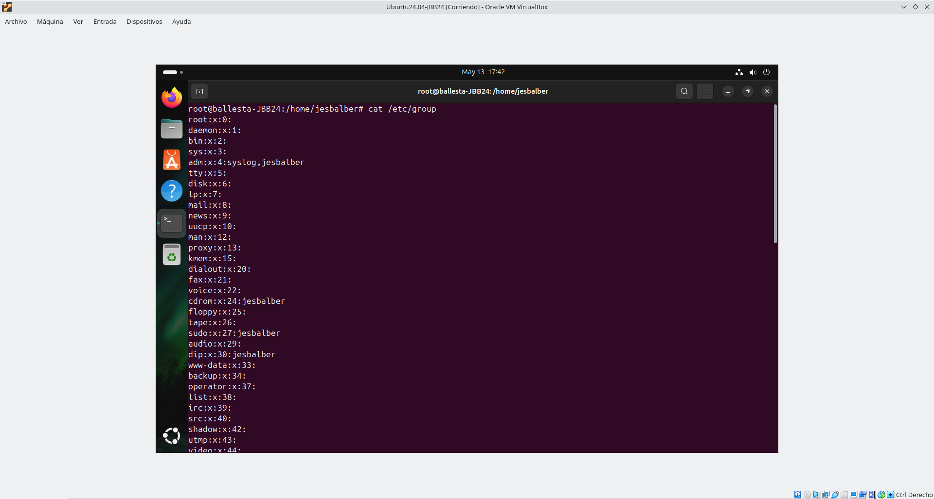
/etc/hostname:
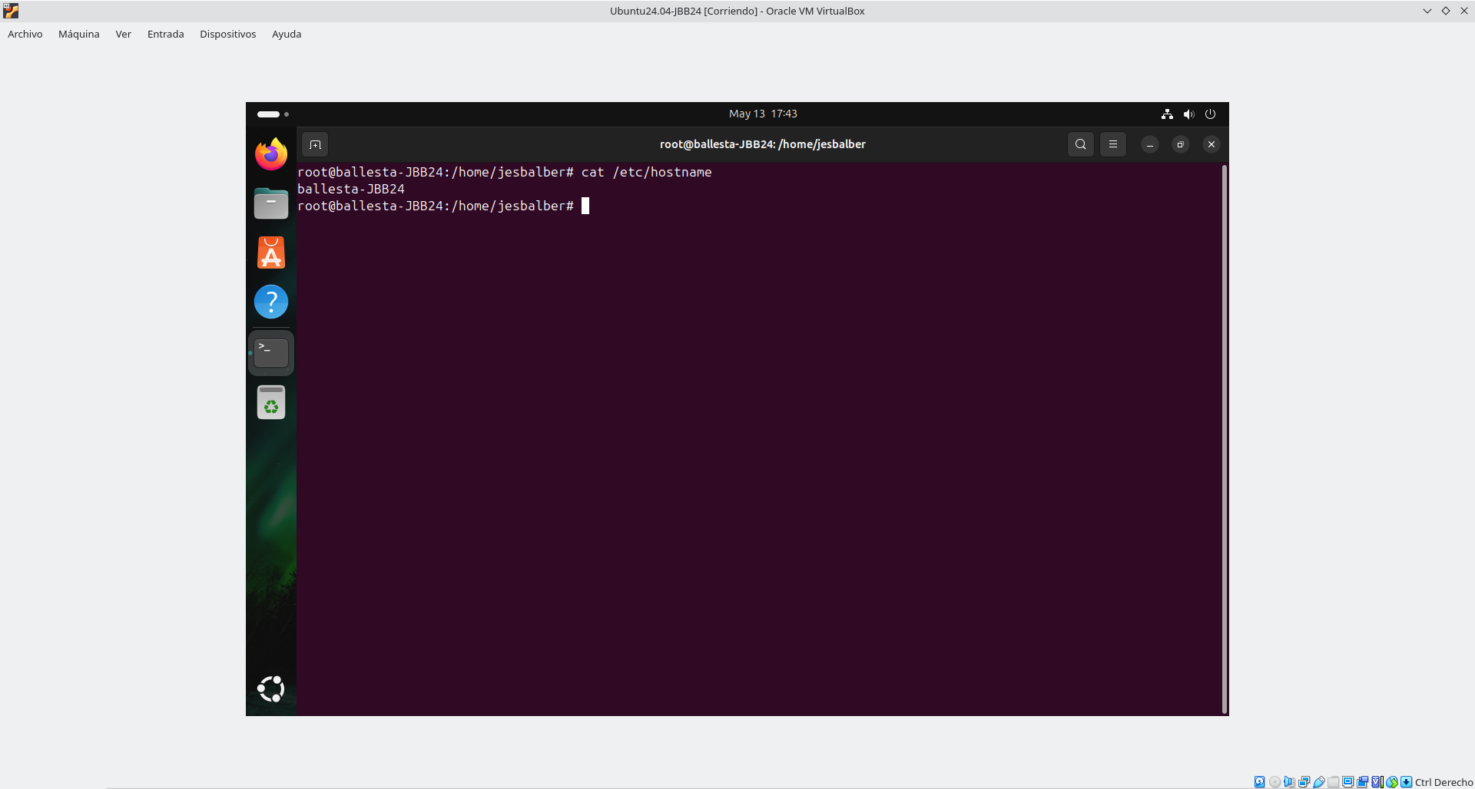

/etc/hosts:
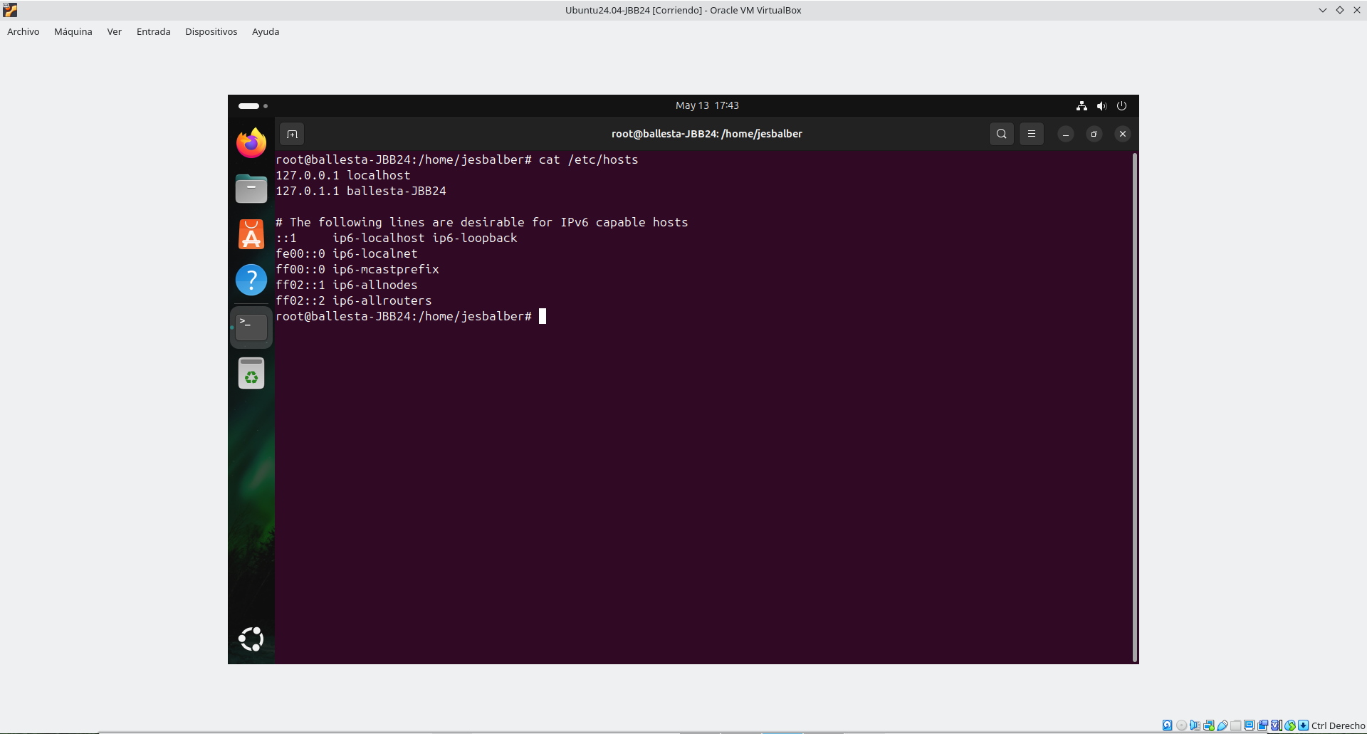
/etc/fstab:
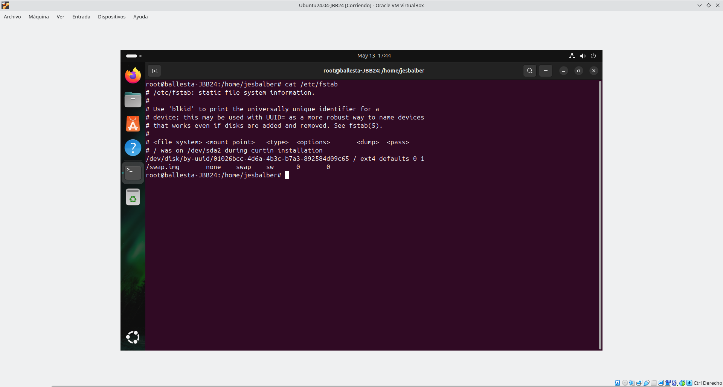

/etc/network/interfaces:
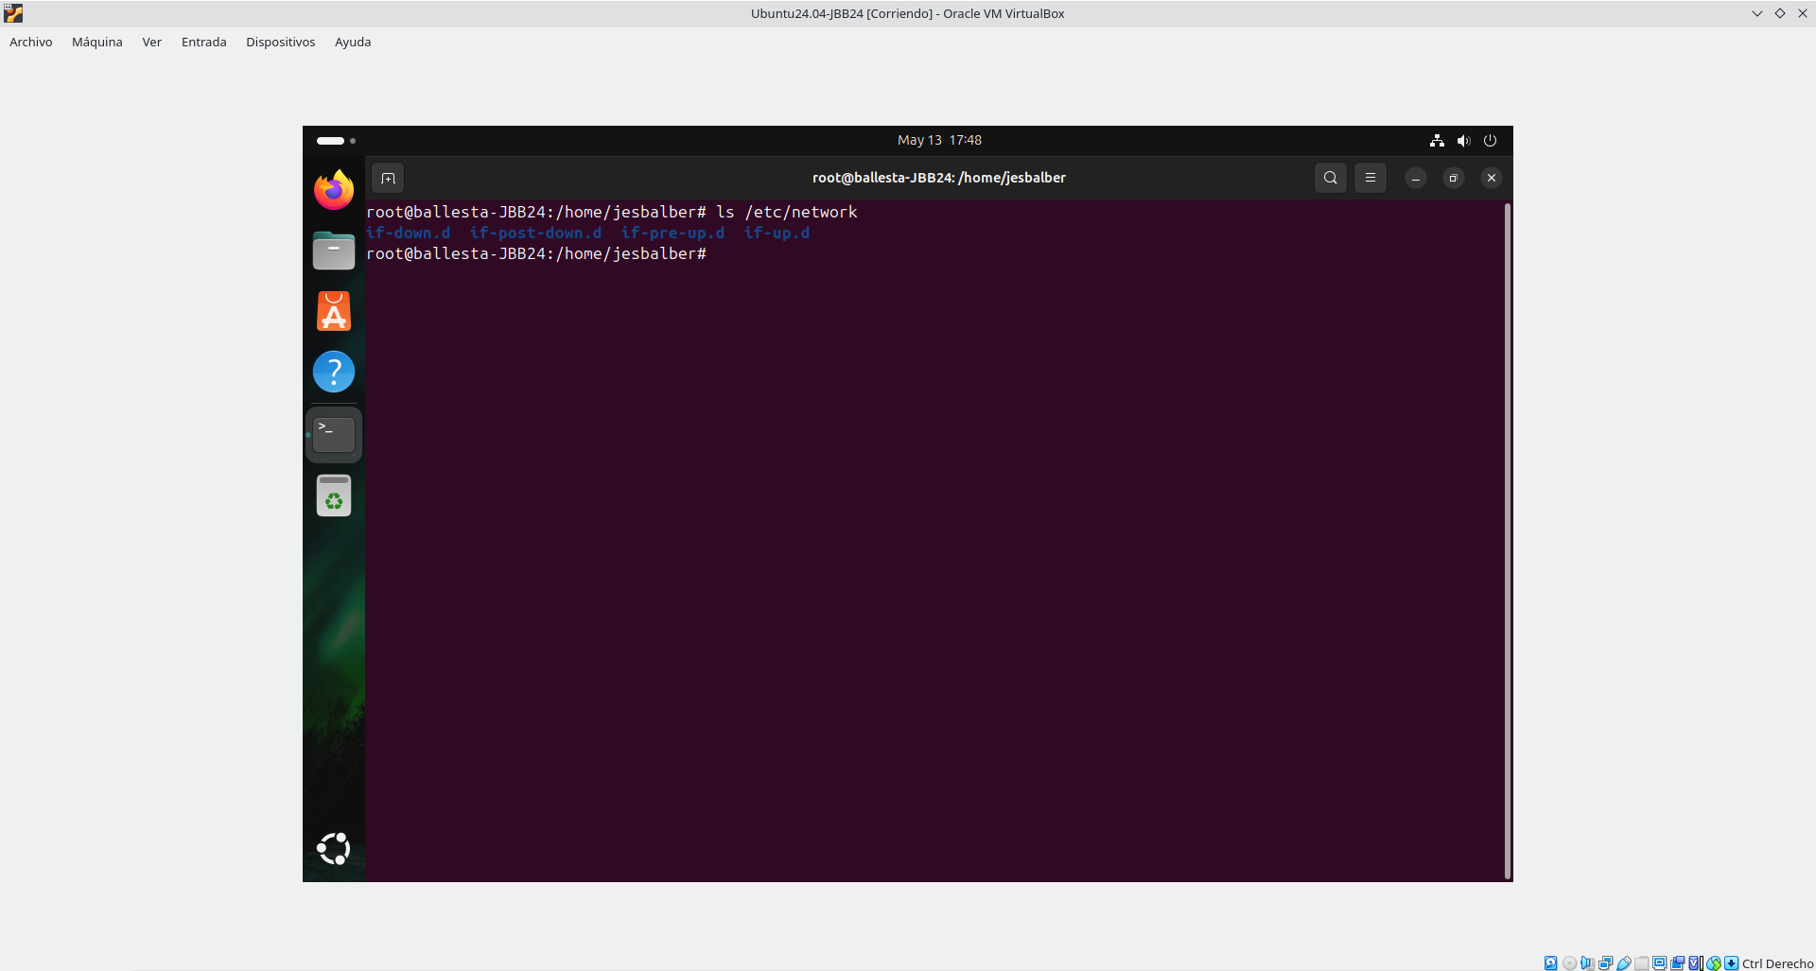

/etc/netplan:

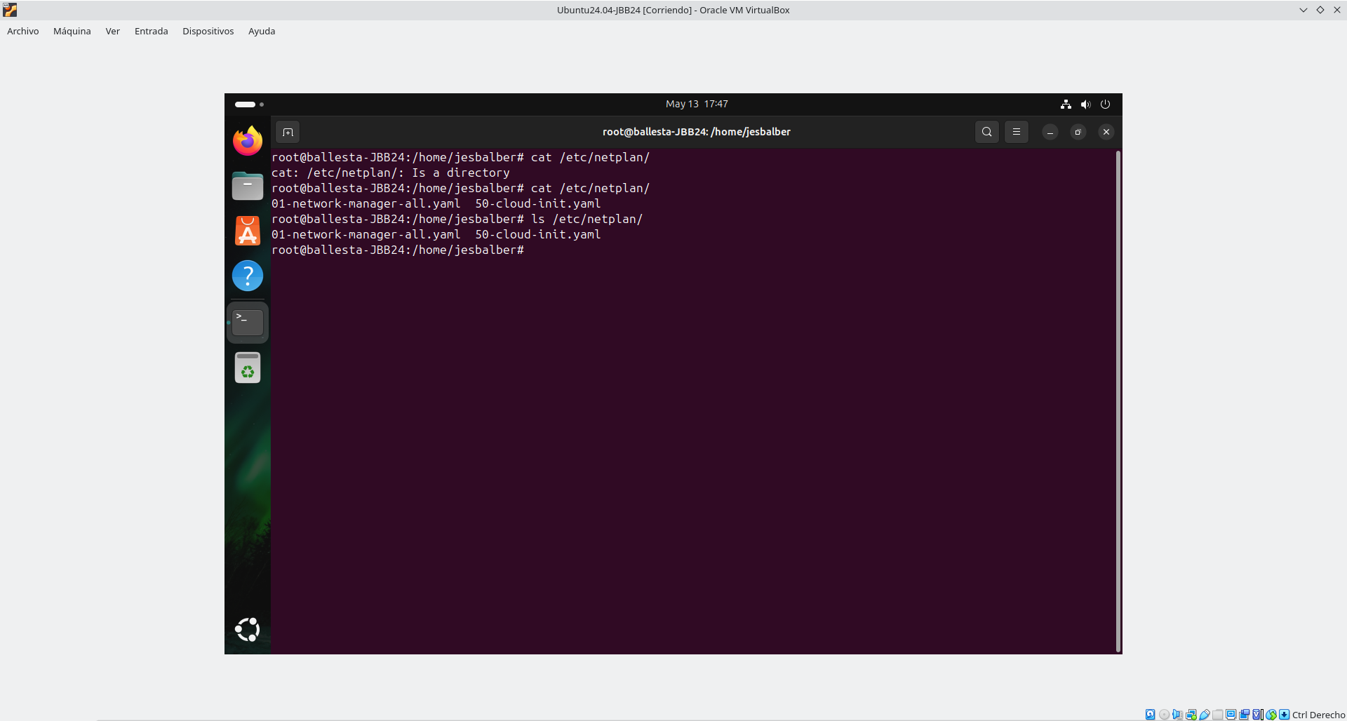

- Run a command to get the Ubuntu version and command history. [Screenshots].
$ uname -a
$ uname -v
$ lsb_release -a
$ history
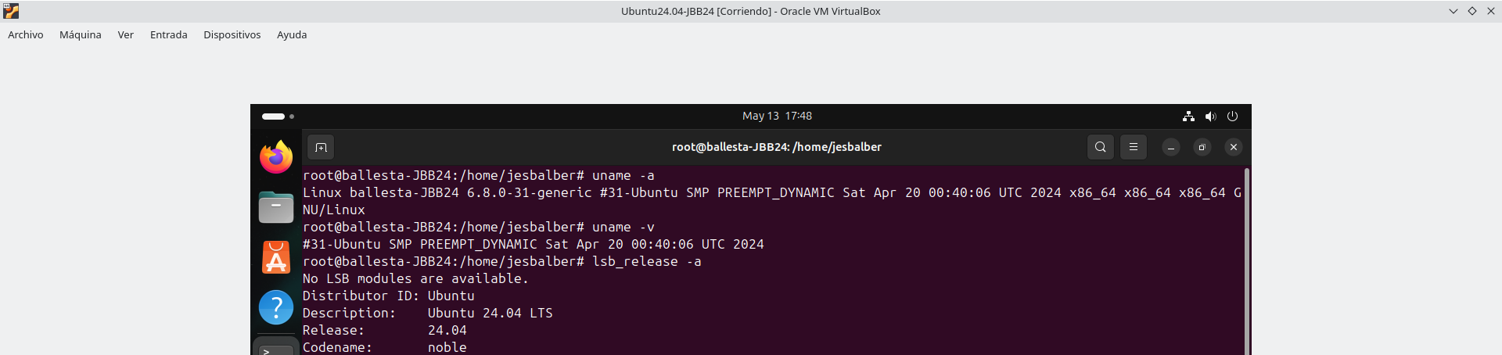
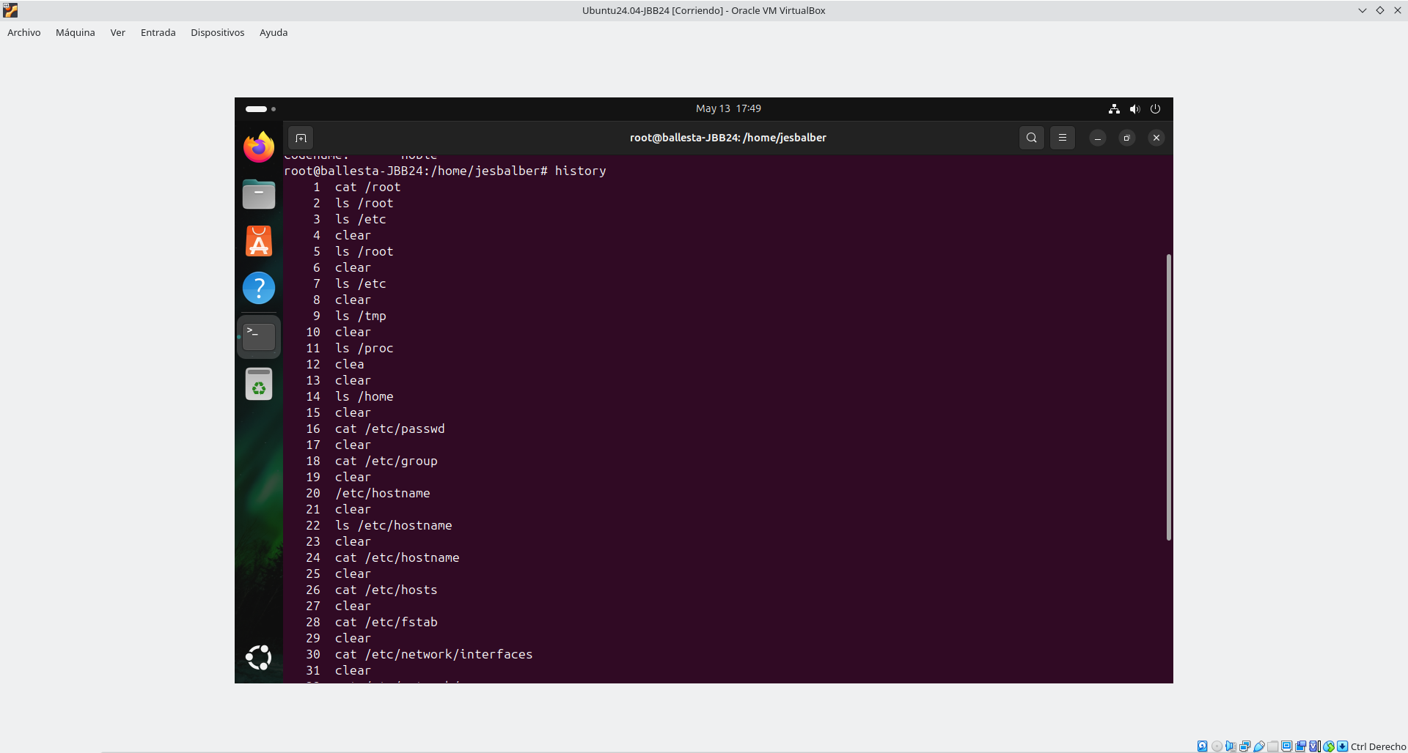

- Take screenshots of the commands used for entering to the directory /proc, and for viewing the content of the files with the information: CPU, memory, system version, and time the system is up and running.
CPU:
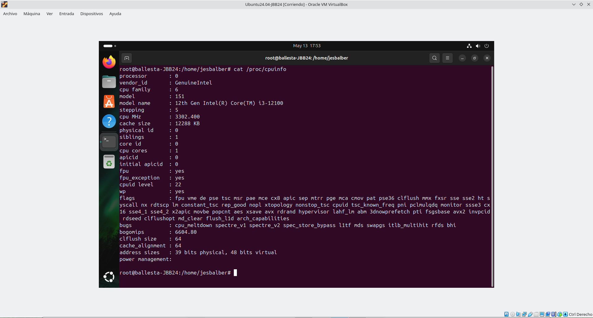
memory:
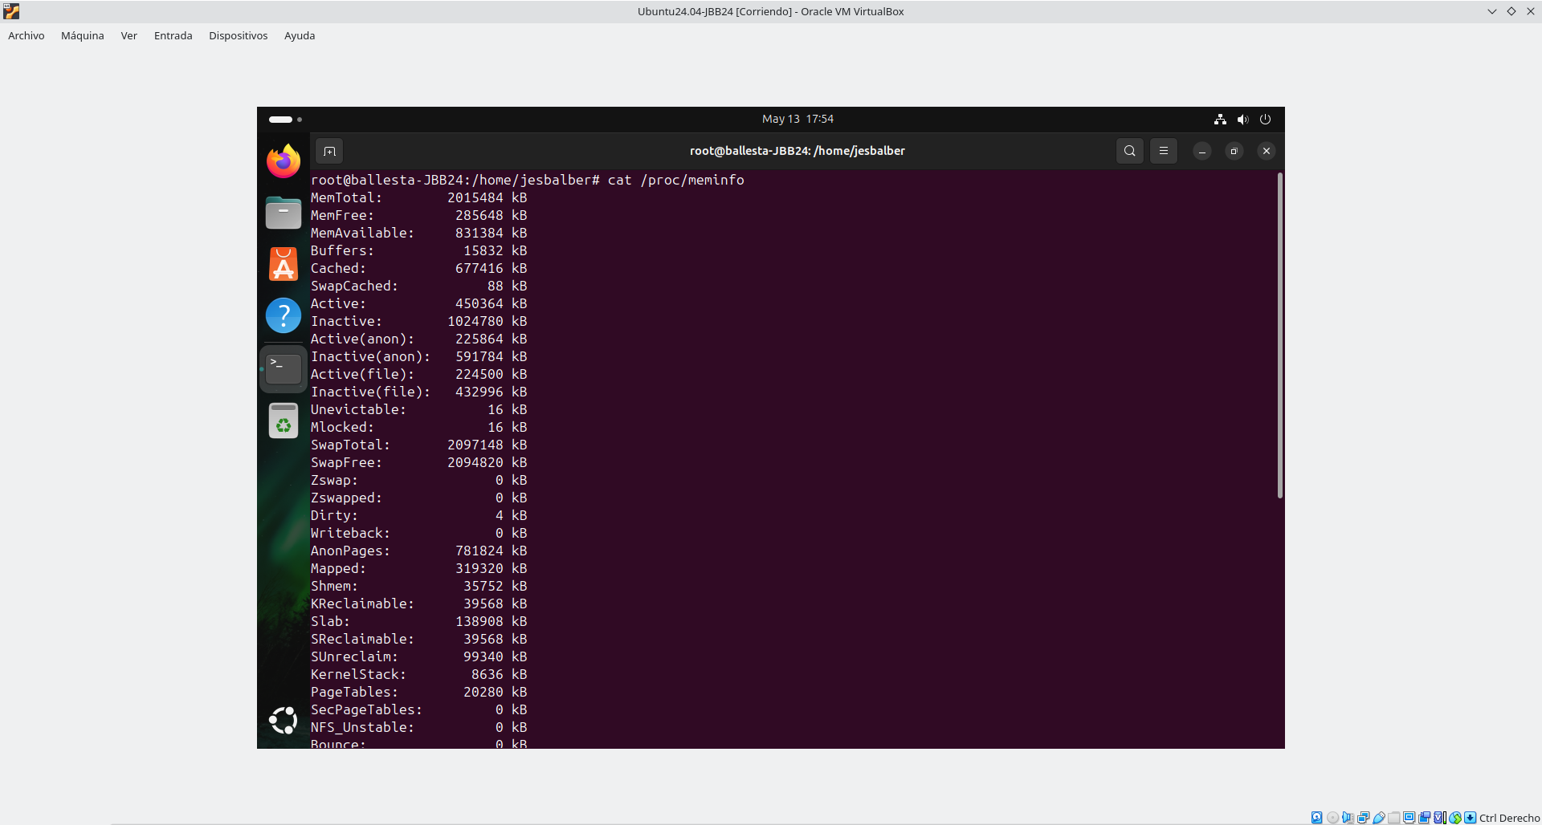

system version:
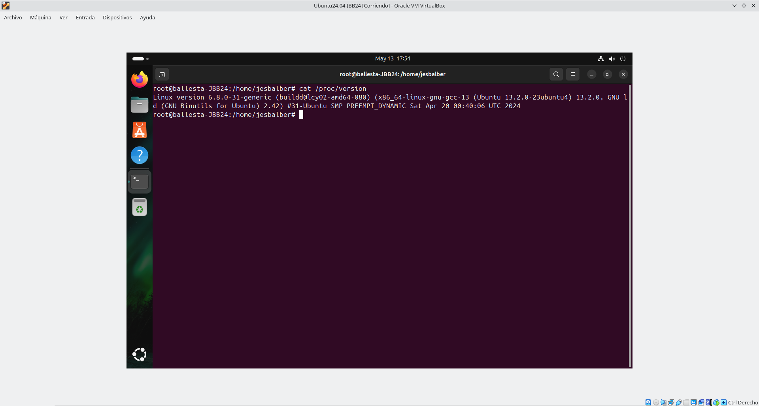
time when the system is up:
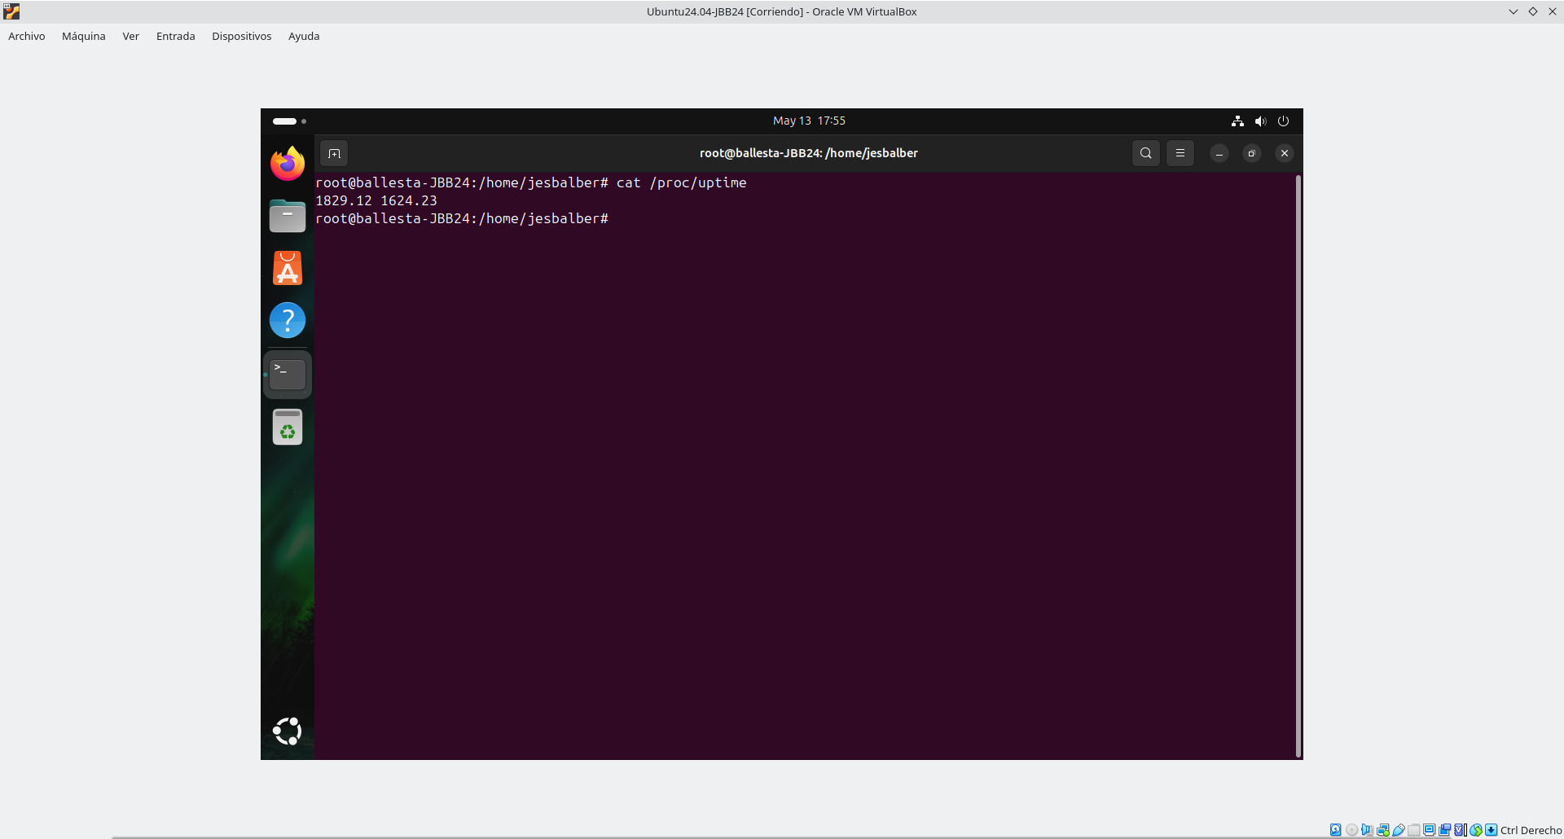

Upgrade system
- We open a command terminal, authenticate ourselves as root and proceed to upgrade the system.
$ sudo su
# apt-get update && apt-get upgrade -y
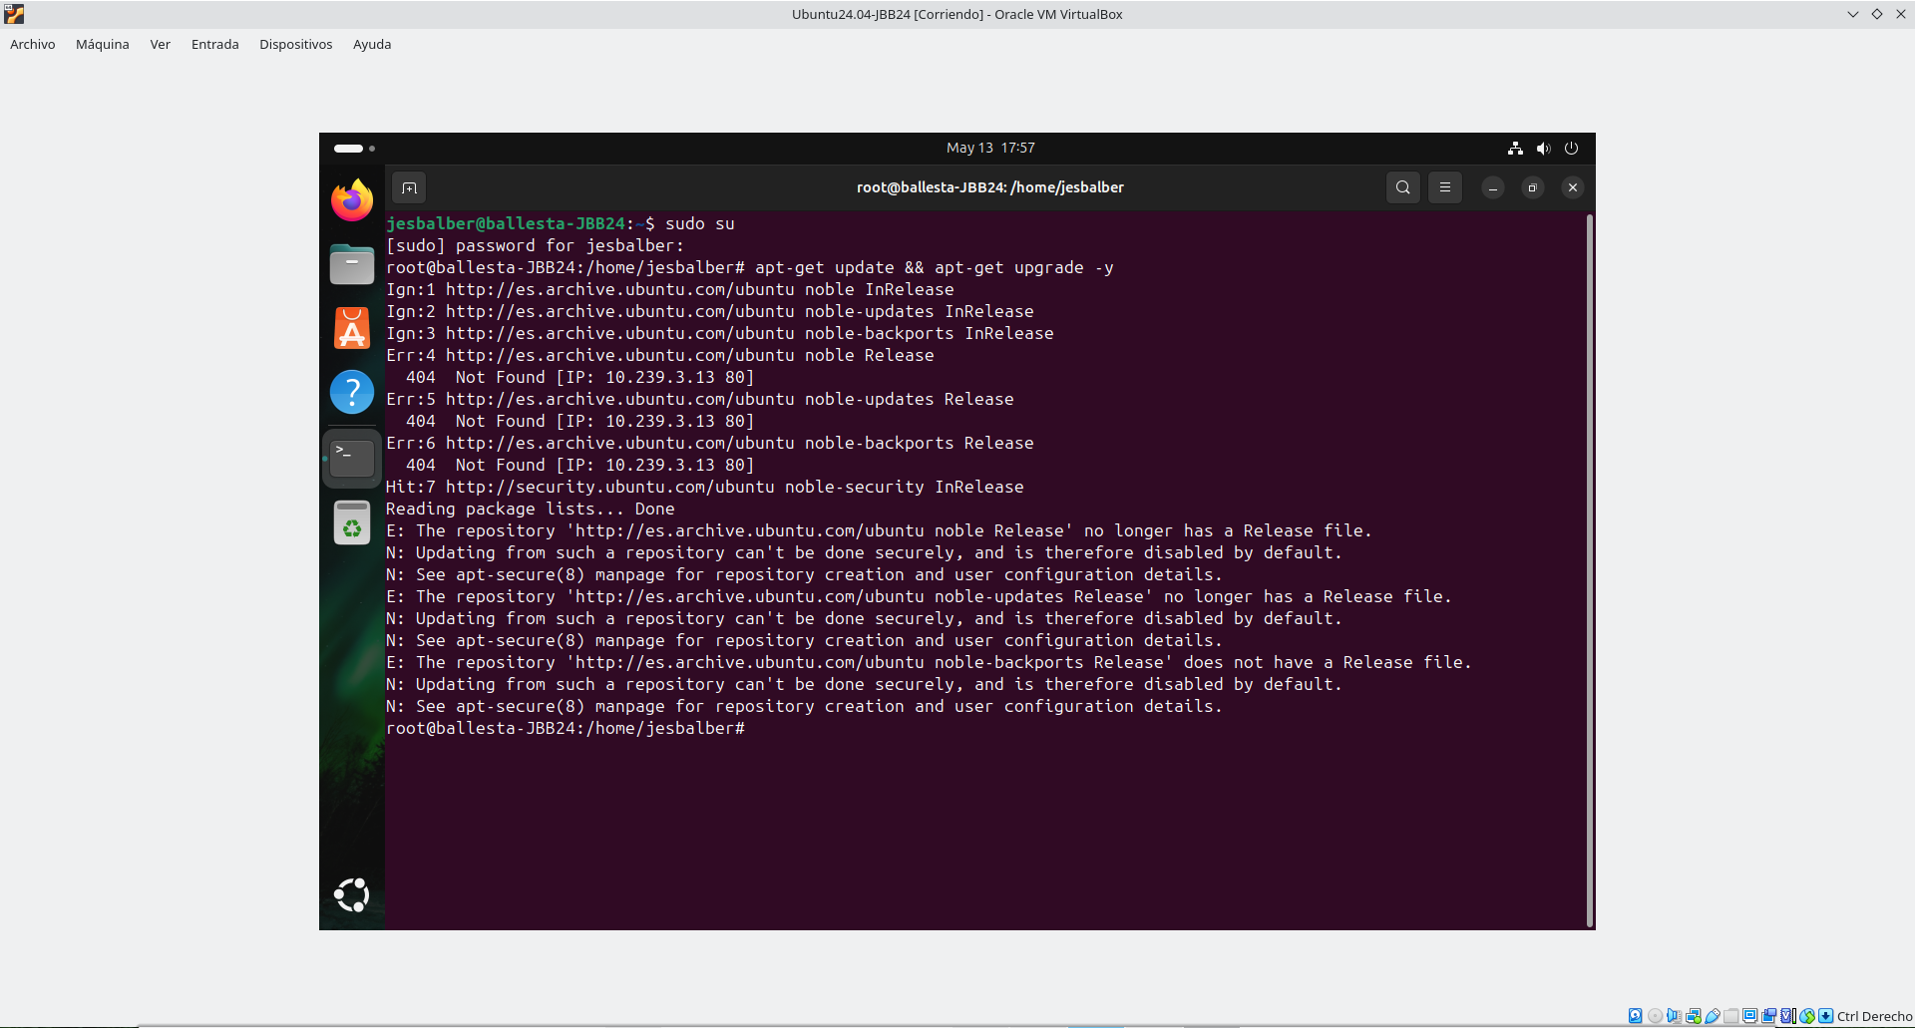
- Setup VirtualBox Guest Additions or VMWare Tools.
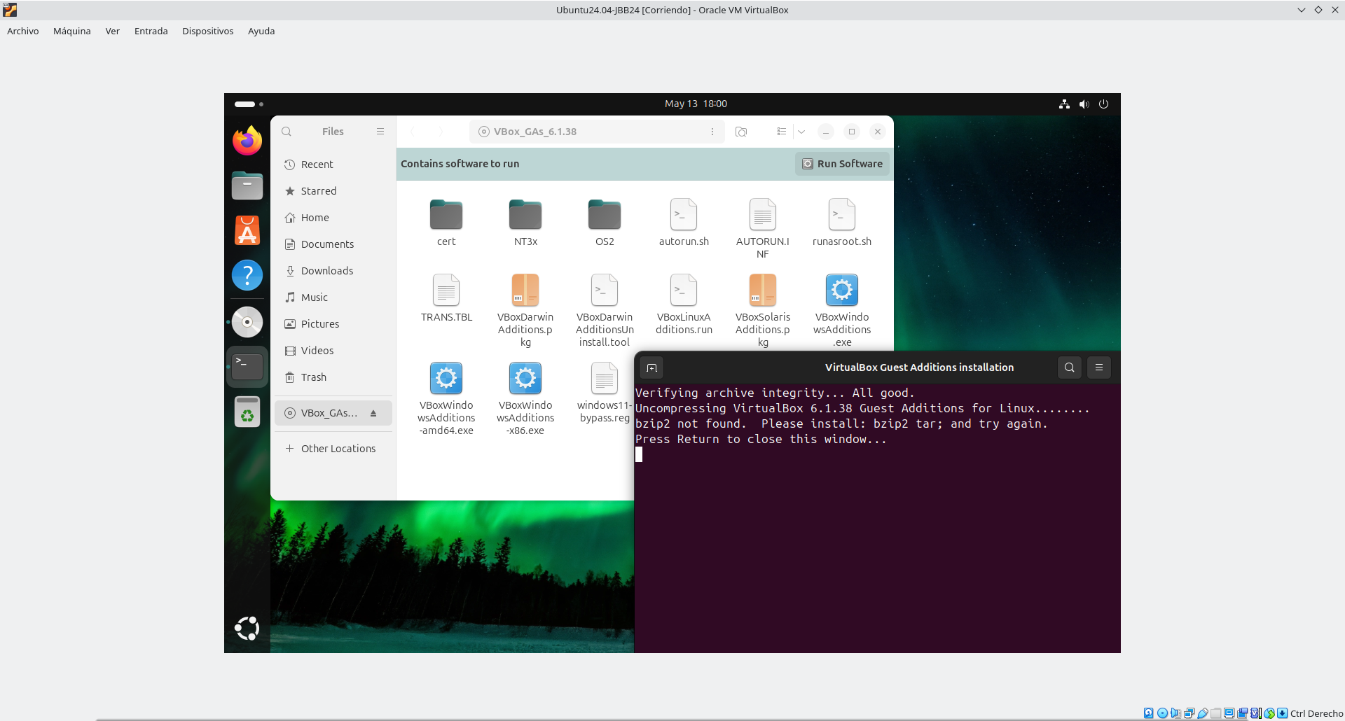

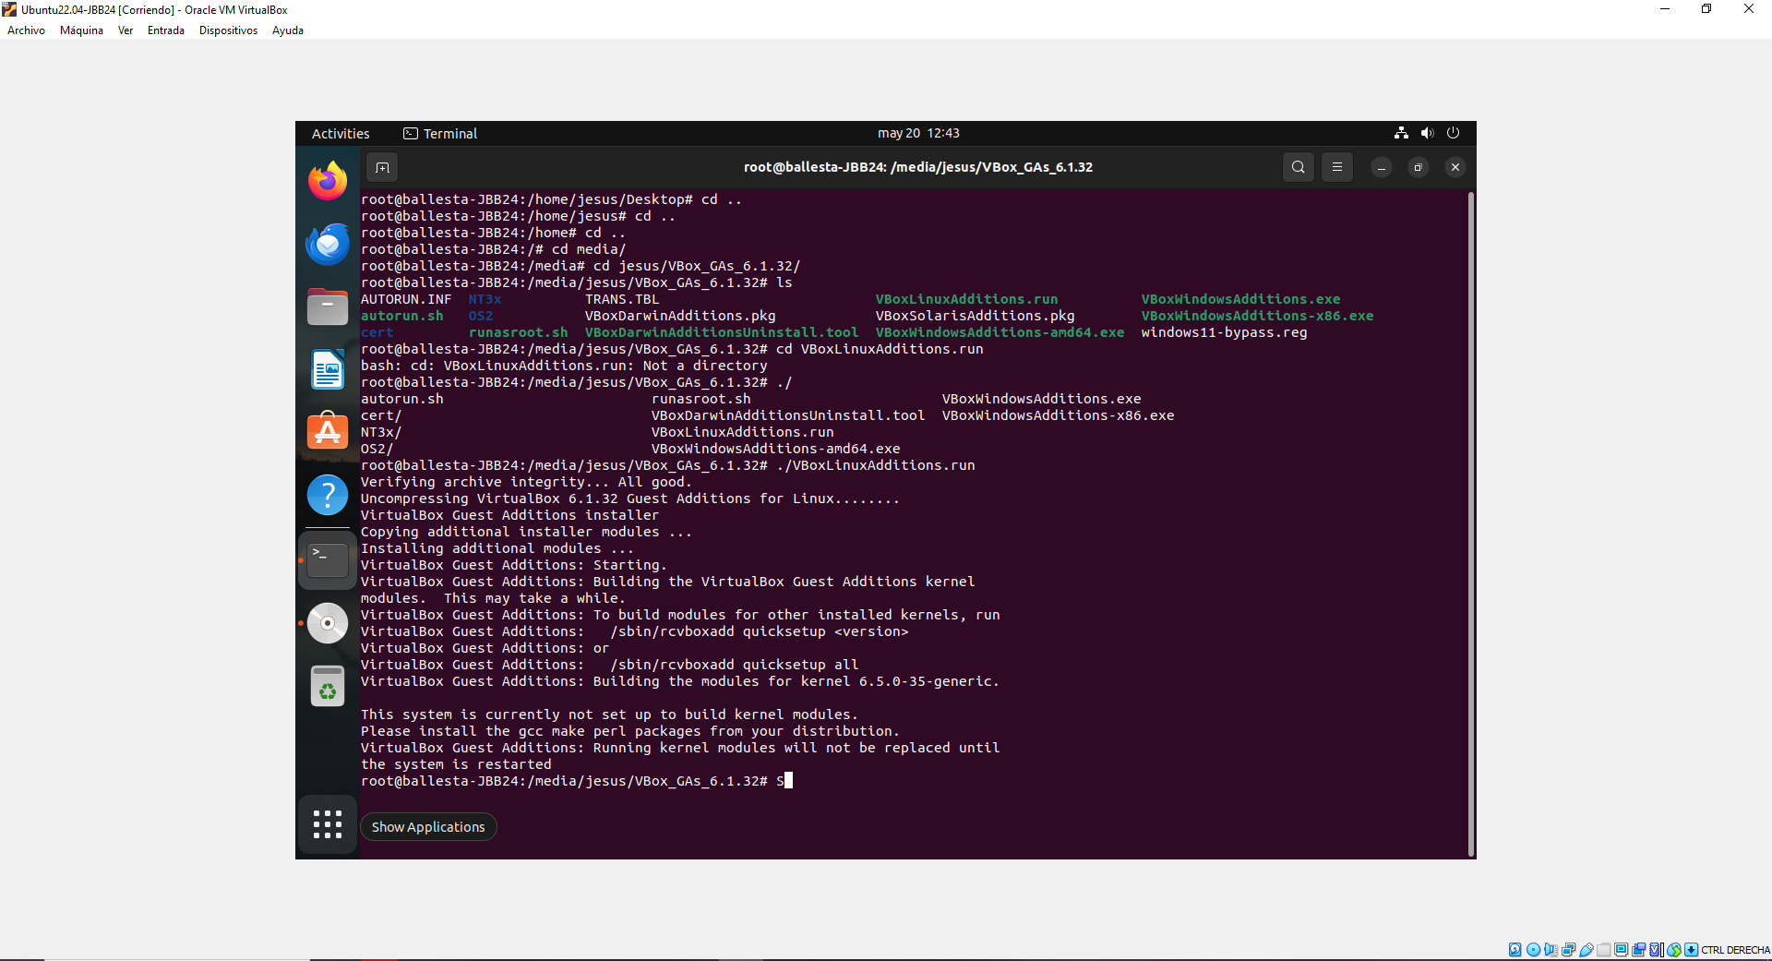

Installing and uninstalling applications

Ubuntu software
- We open the Ubuntu Software package manager and update all pending packages.
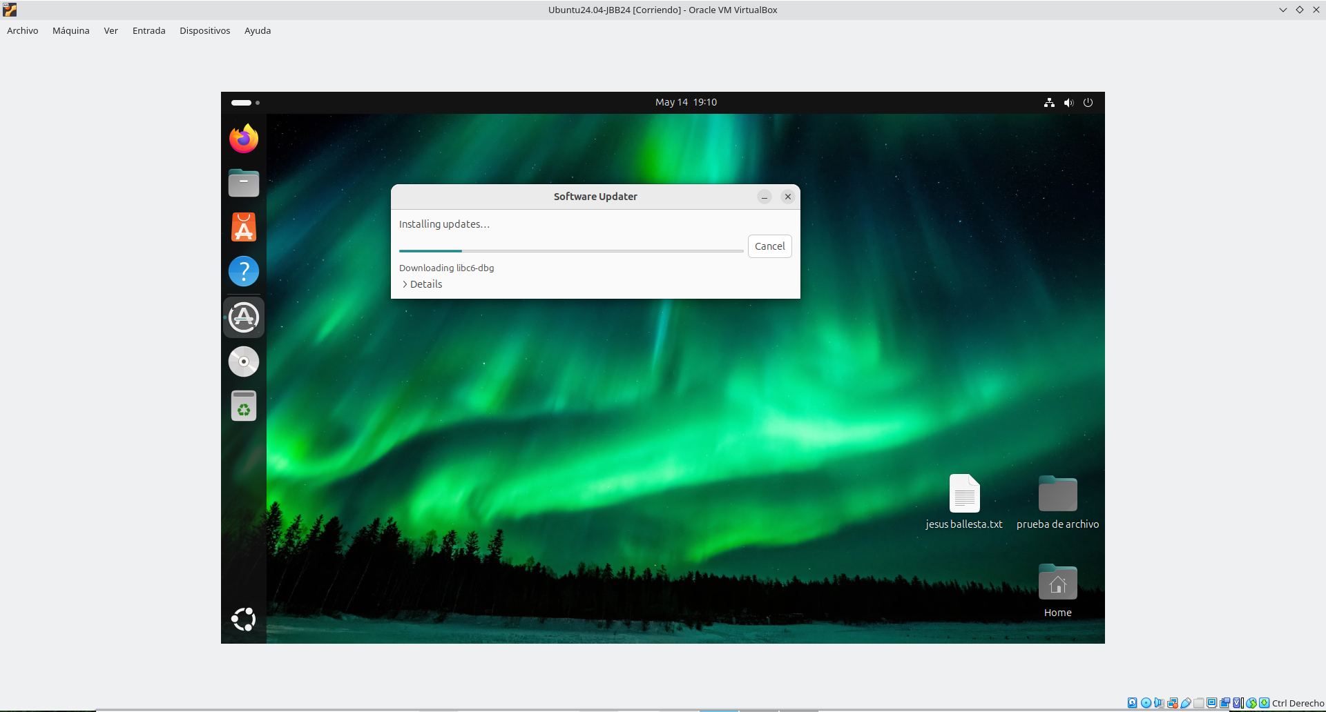
- Install the following applications:
  - Chromium.
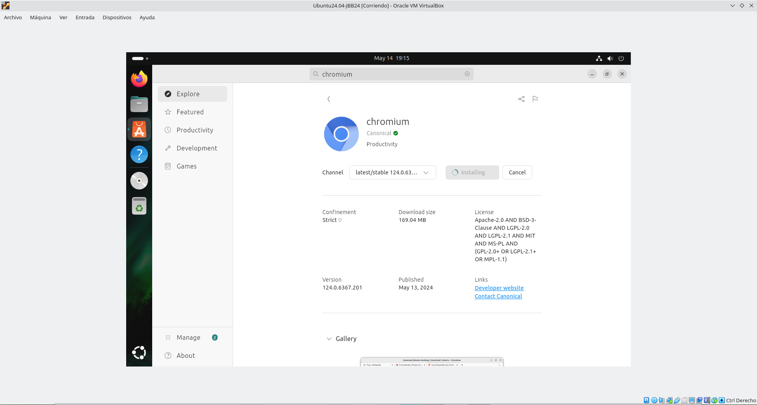
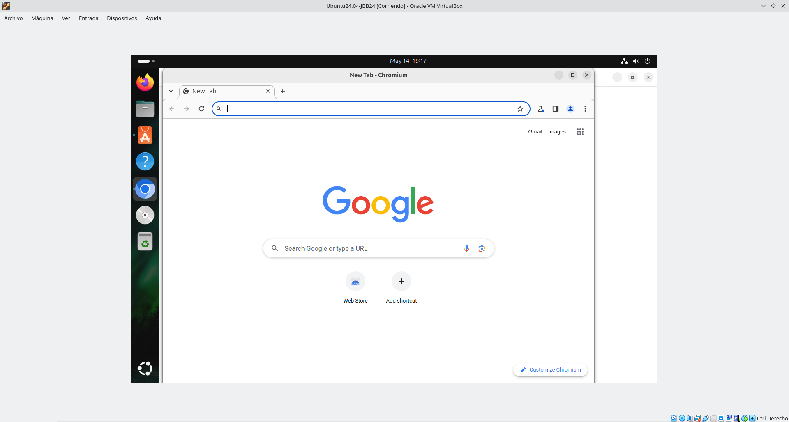
  - Tor-Browser.
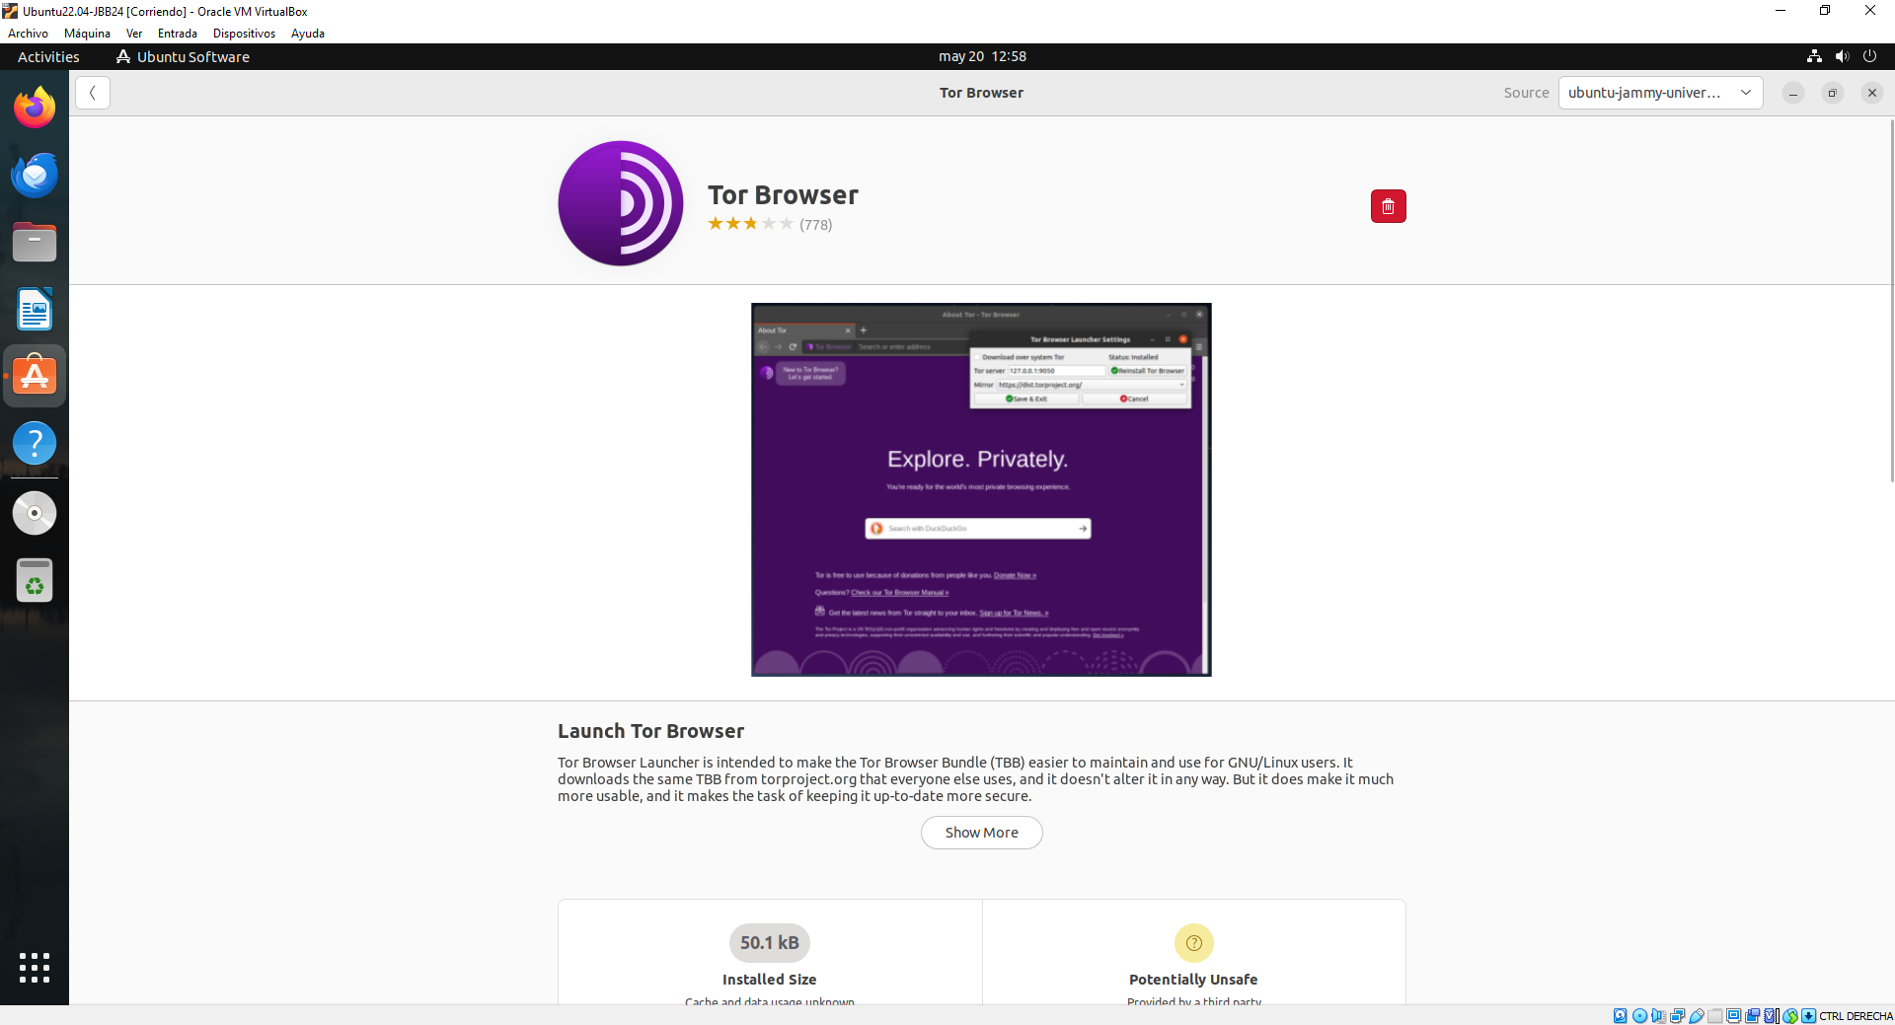

  - Synaptic Package Manager.
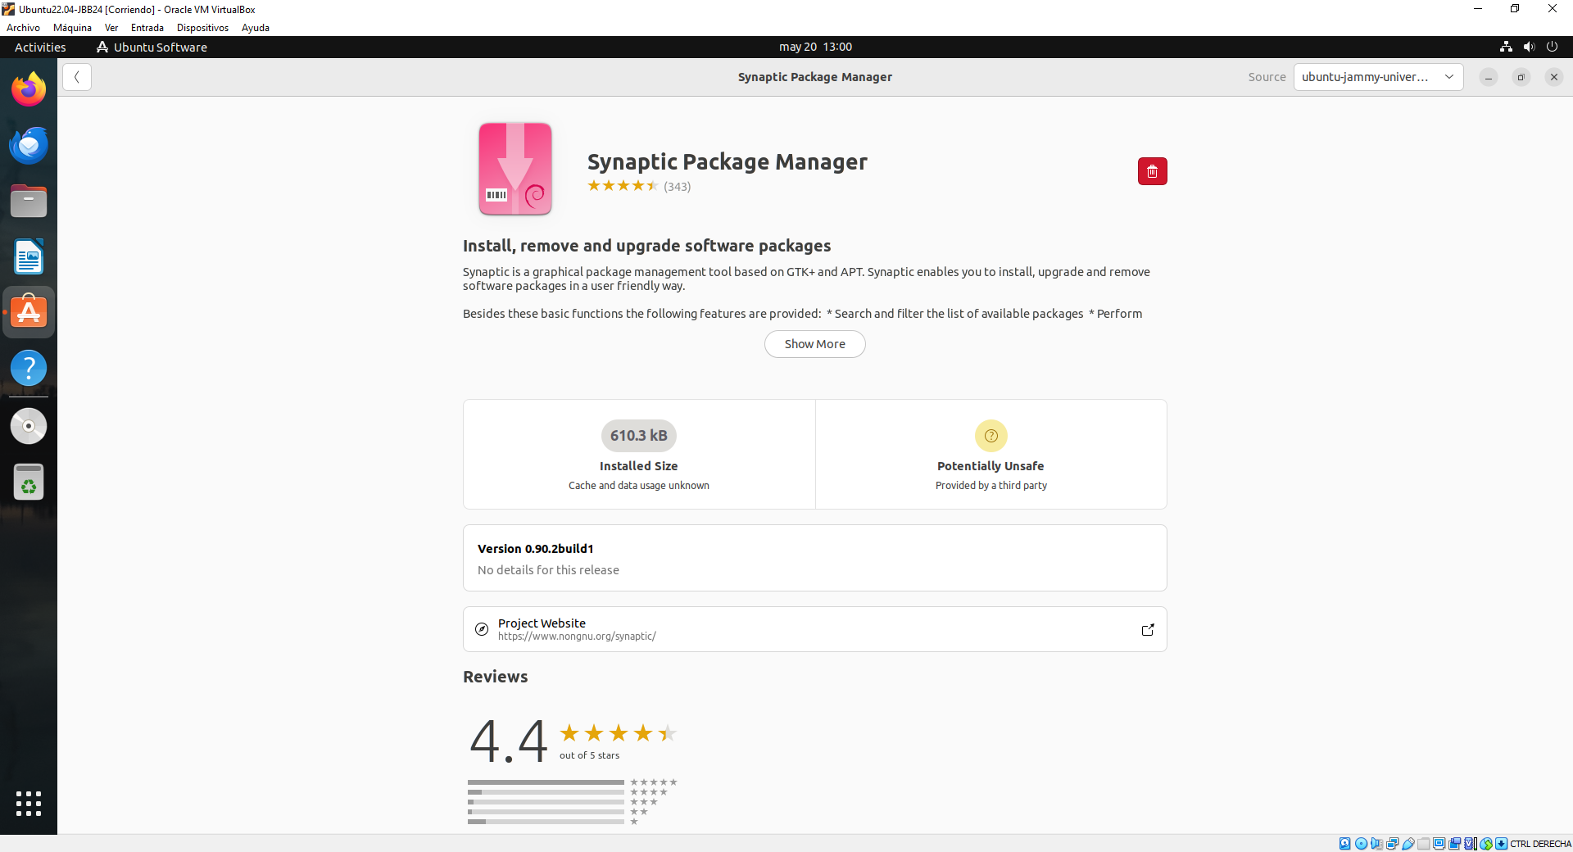
- Uninstall Mozilla Firefox. [Screenshot].

apt-get / apt
- We learn how apt-get works for this we consult the Linux manual. [Screenshot].
$ man apt
Option | Description
install | Is used to update the local package index.
remove | Is used to uninstall packages from the system
purge | Is used to completely remove a package and its associated configuration files from the system
update | Is used to update +9 the local package index on Debian-based systems.
upgrade | Is used to upgrade the currently installed packages on your system to their latest available versions
-cache show | Is used to display detailed information about a package available from the APT repositories

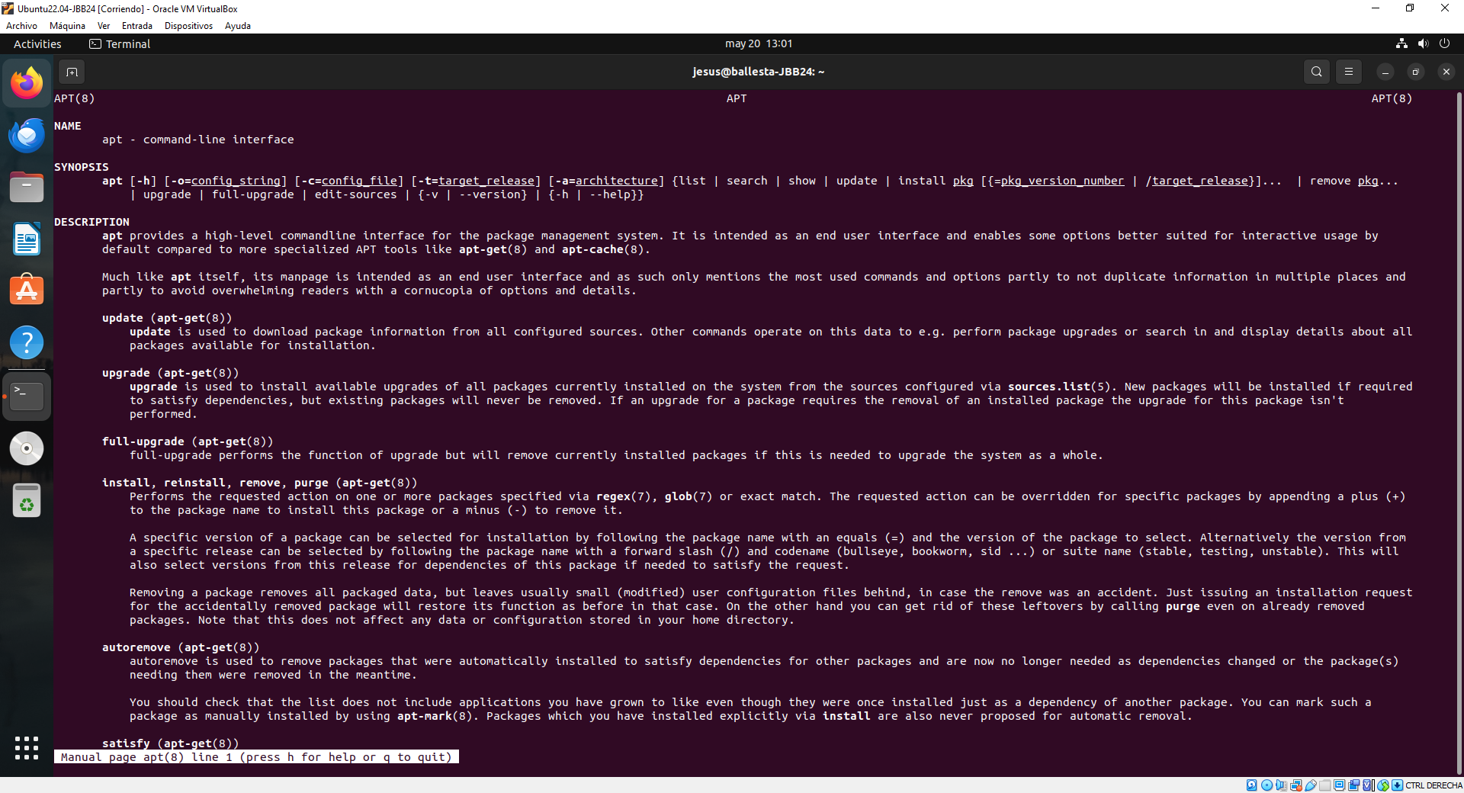

- Install aptitude package manager:
$ sudo su
# apt-get update
# apt install aptitude -y
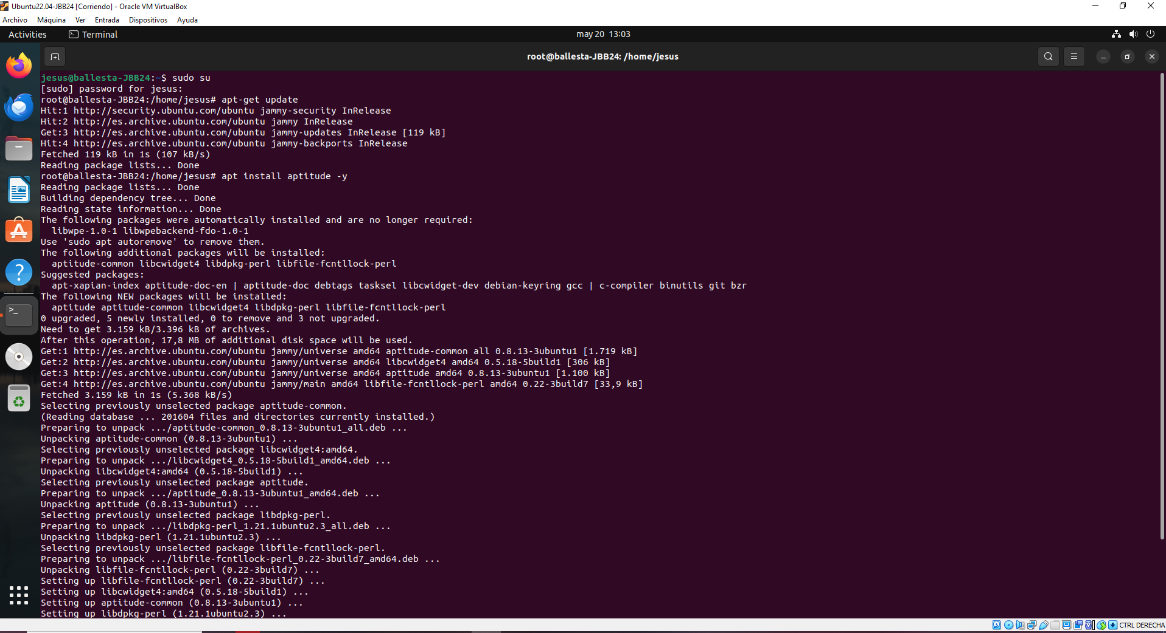

Snap
- We install Visual Studio Code editor and VLC Media Player. [Screenshot].
# snap version
# snap install code –classic
# snap install vlc
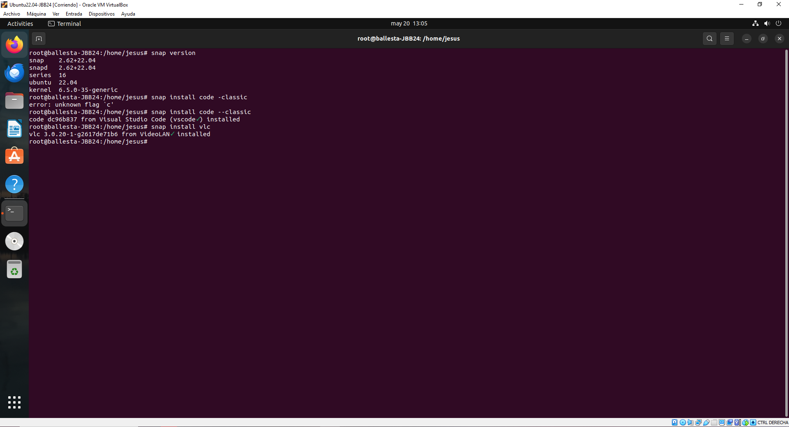

- We find out how the snap command works and its main options. We complete the table. [Screenshot].
$ man snap
Option | Description
version | Is used to display the current version of the snapd package manager
list | Is used to display a list of all snap packages installed on your system
find | Is used to search for snap packages available in the snap store
info | Provides detailed information about a specific snap package available in the snap store
install | Is used to install snap packages from the snap strore
remove | Is used to uninstall snap packages from your system
refresh | Is used to update snap packages to their latest versions from the snap store

Synaptic Package Manager

- Get a screenshot of the Synaptic Package Manager application.
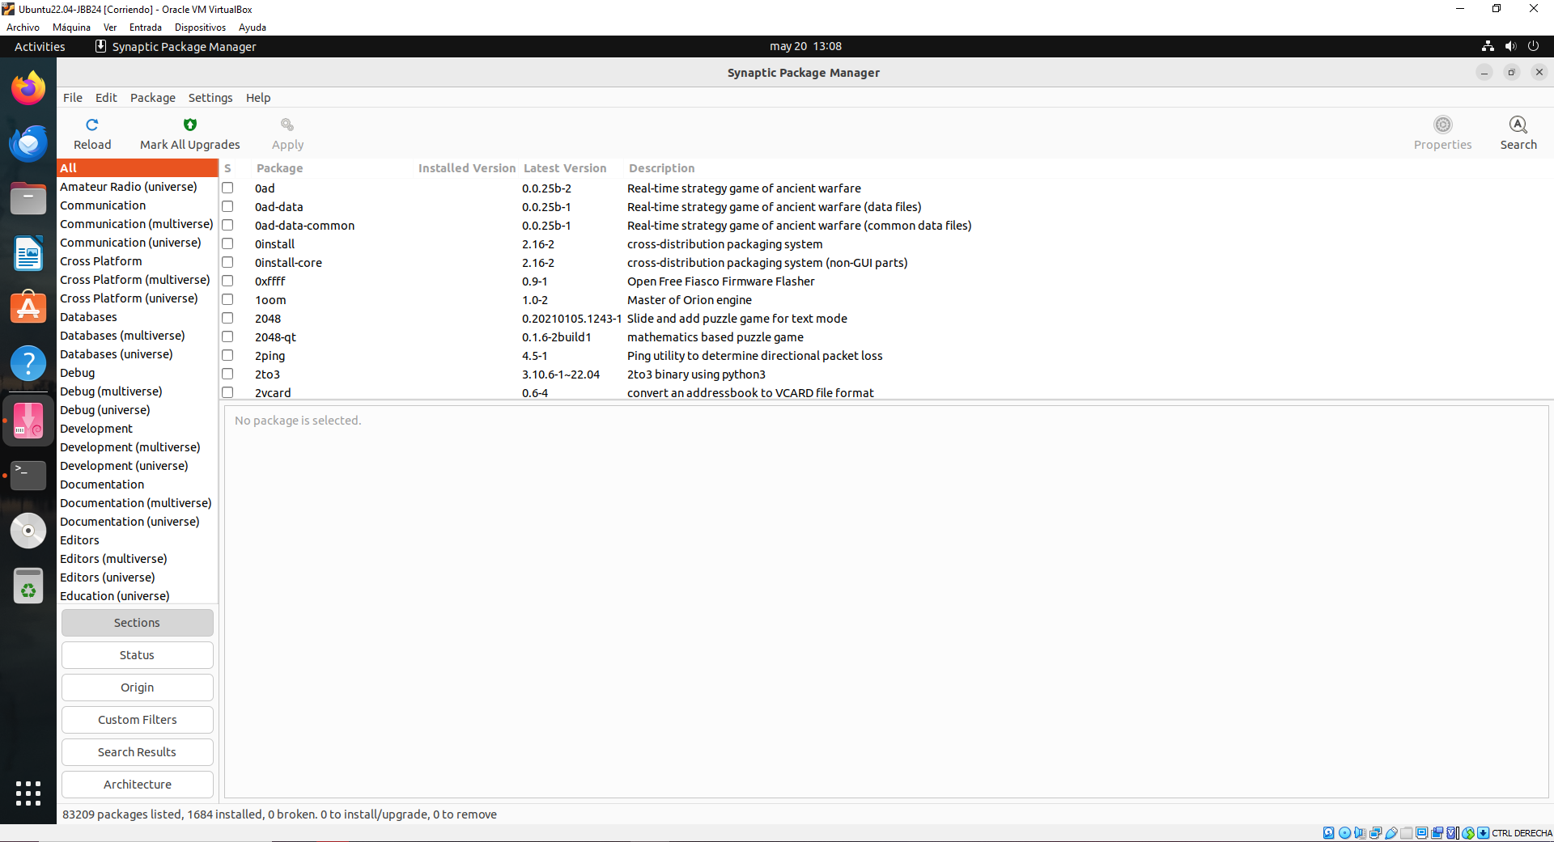

- Search and install the Firefox Internet browser.
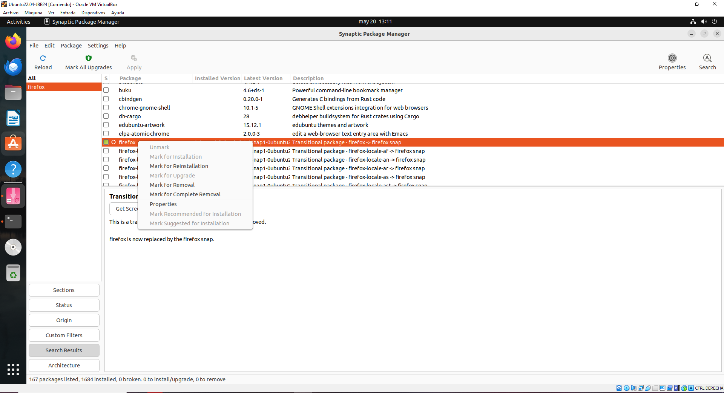
Firefox is installed and is not necessary to install other time

Aptitude
- Install by using aptitude the TUI text editor called joe (search in Not Installed Packages/editors).
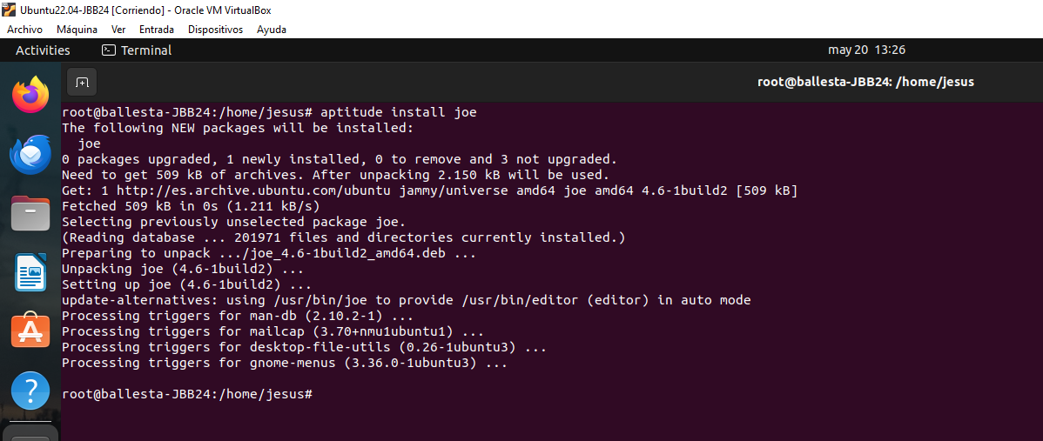

- Run commands to search the package “scratch” in repositories, and another to show its information.
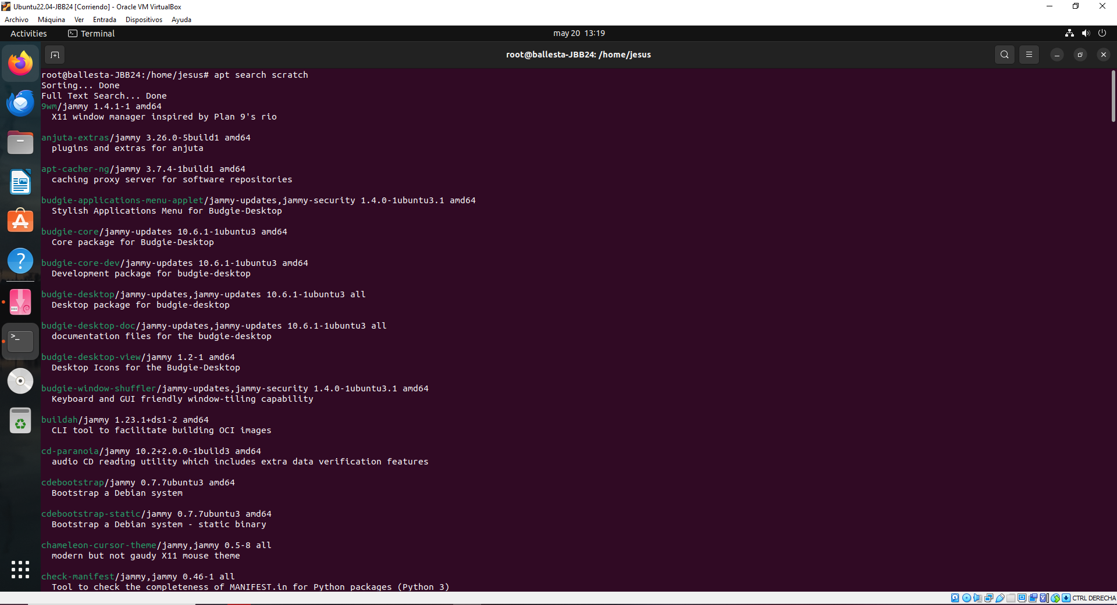
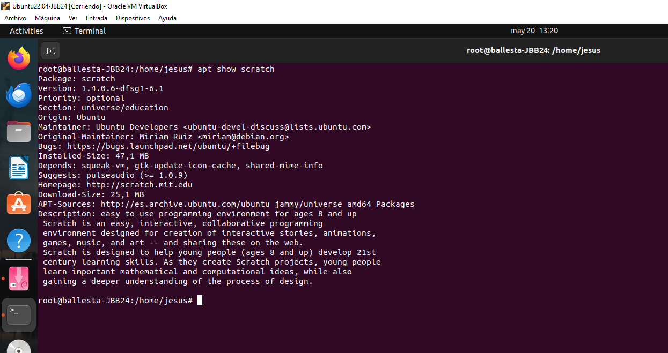

- Install by using aptitude scratch (educational tool), besides, take screenshots of the execution of scratch.
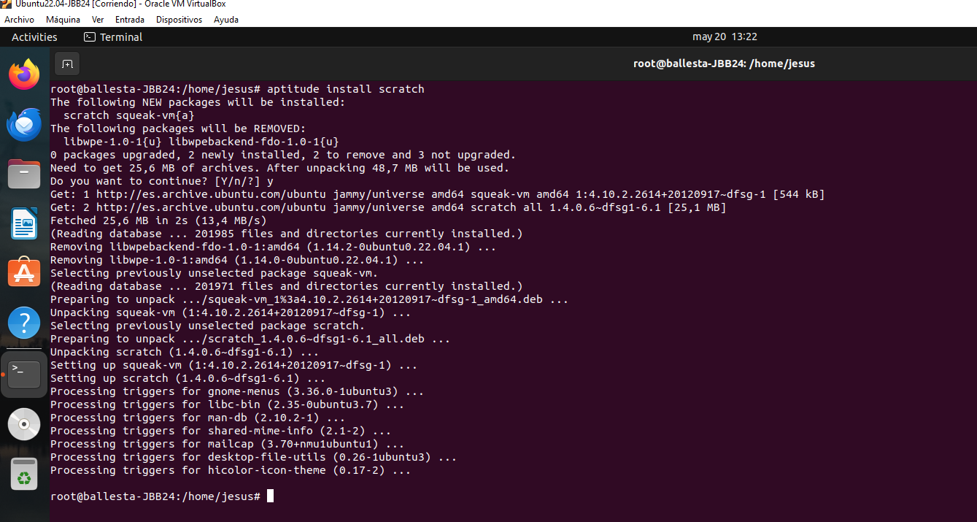
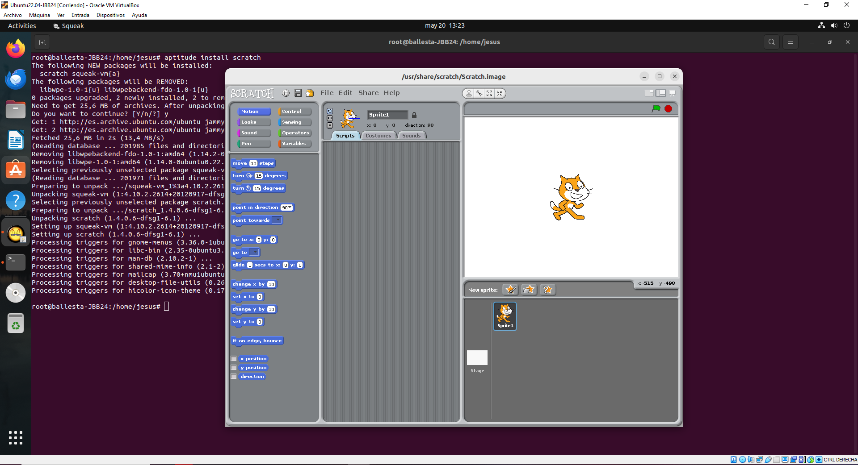

- Uninstall by using aptitude the application scratch (programming environment).
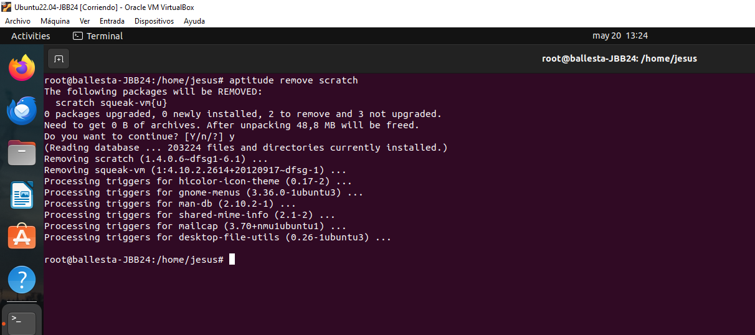
- By using aptitude: install gedit the GNOME the graphical text editor or show if it’s installed.
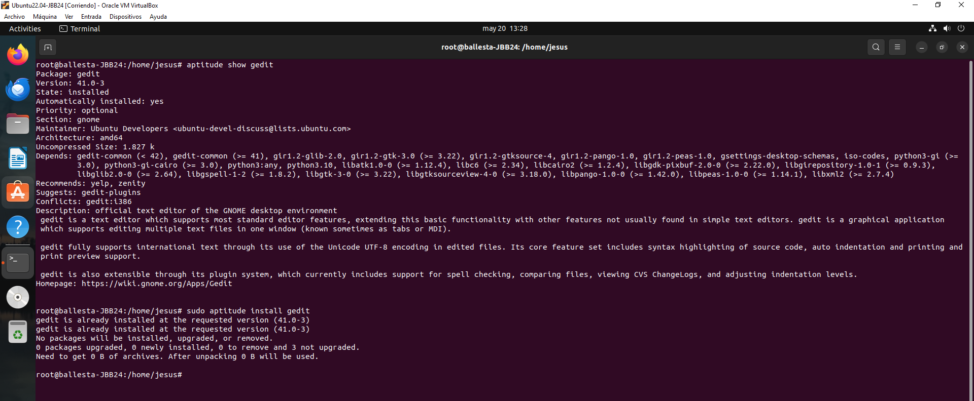

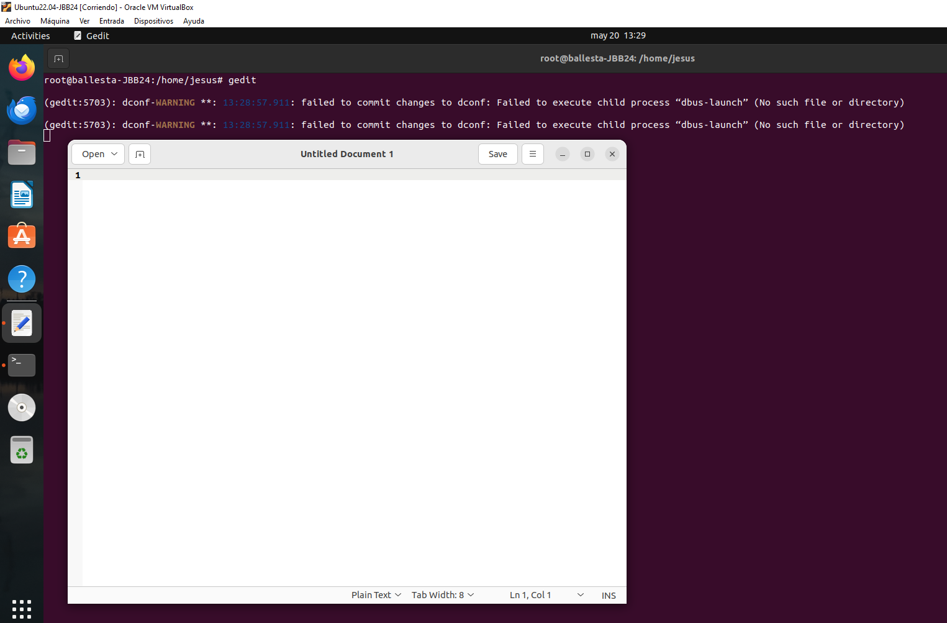
- By using joe, create a file on your desktop, called JOE-doc-<codId>.txt that contains your full name.
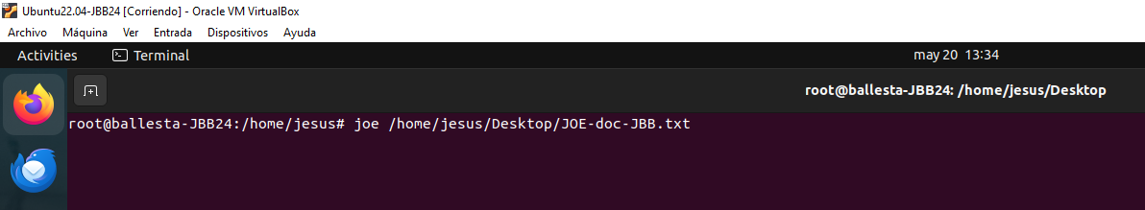
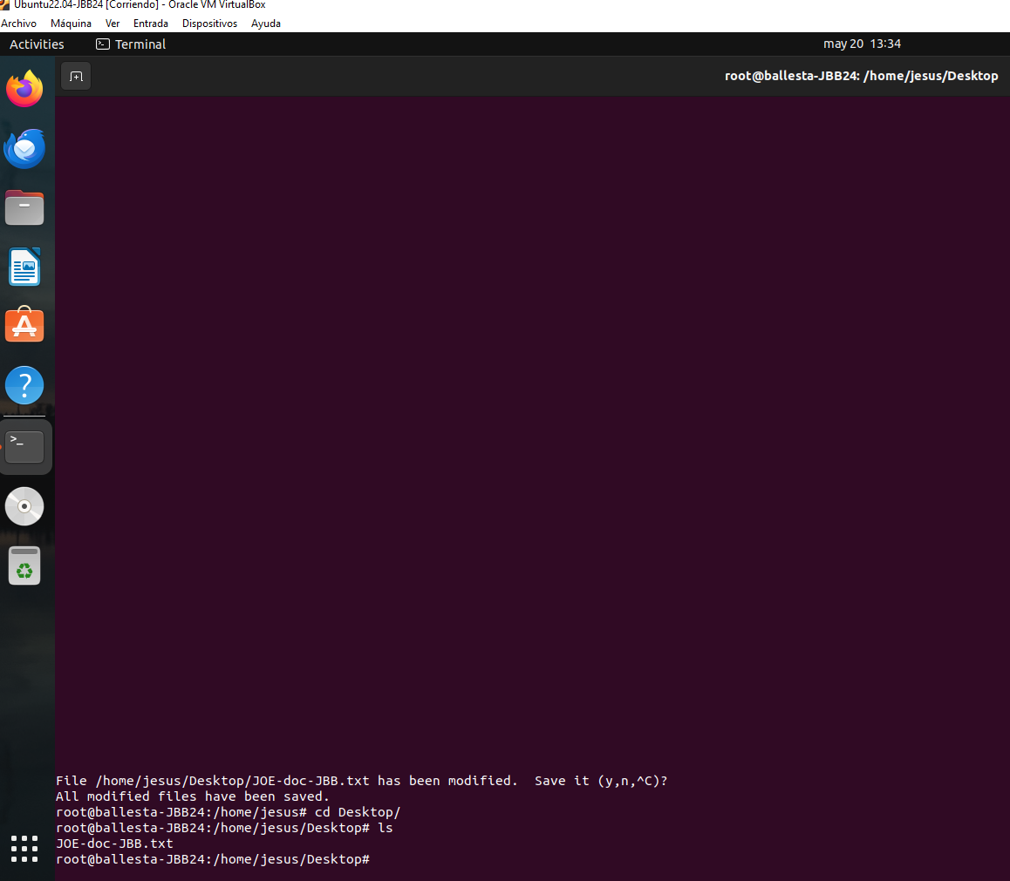
- By using nano, create a file on your desktop, named NANO-doc-<codId>.txt that contains your full name.
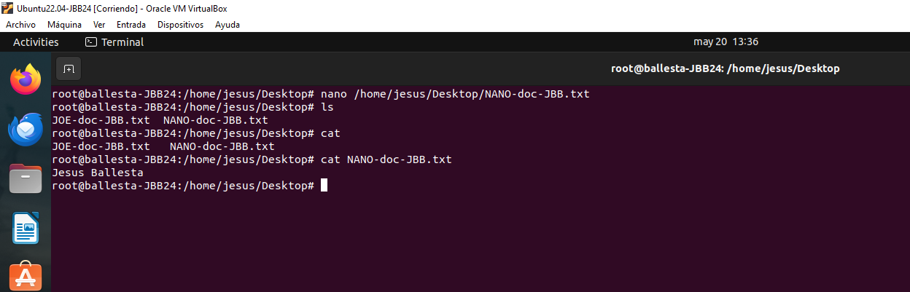

- By using gedit, create a file on your desktop, named GEDIT-doc-<codId>.txt which contains your full name.
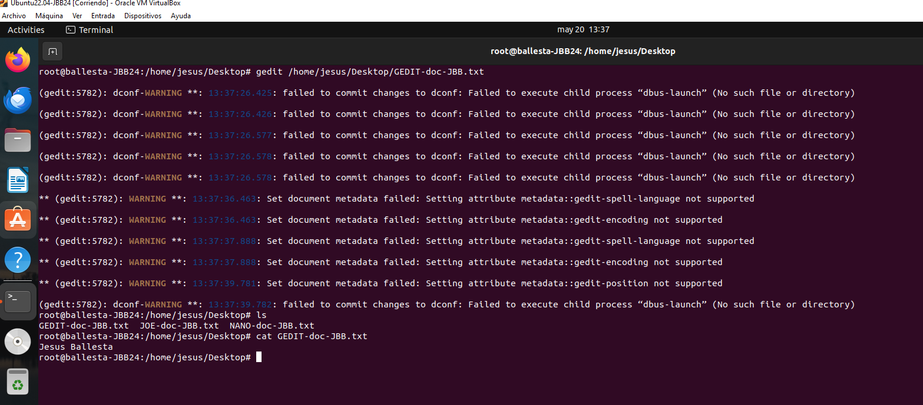
- By using vim (vi), create a file on your desktop, named VIM-<codId>.txt which contains your full name.
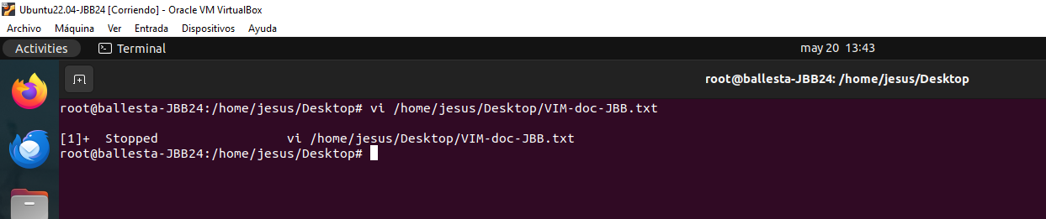
- Uninstall text editor joe by using the command apt forcedly (with no question).
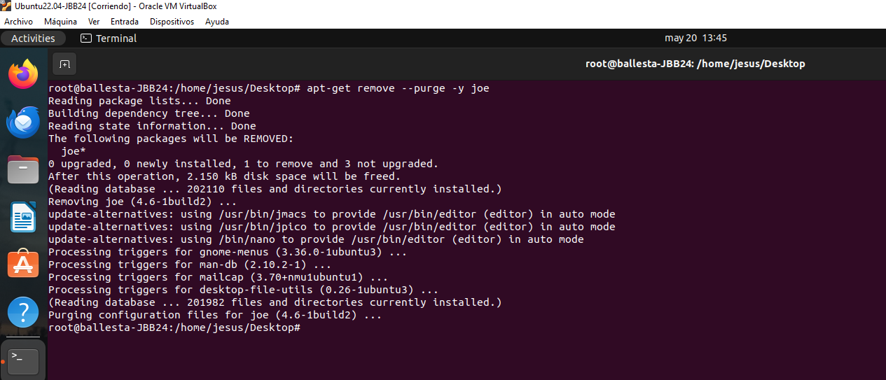

- Install by using a command the application: Synaptic (graphic package manager).
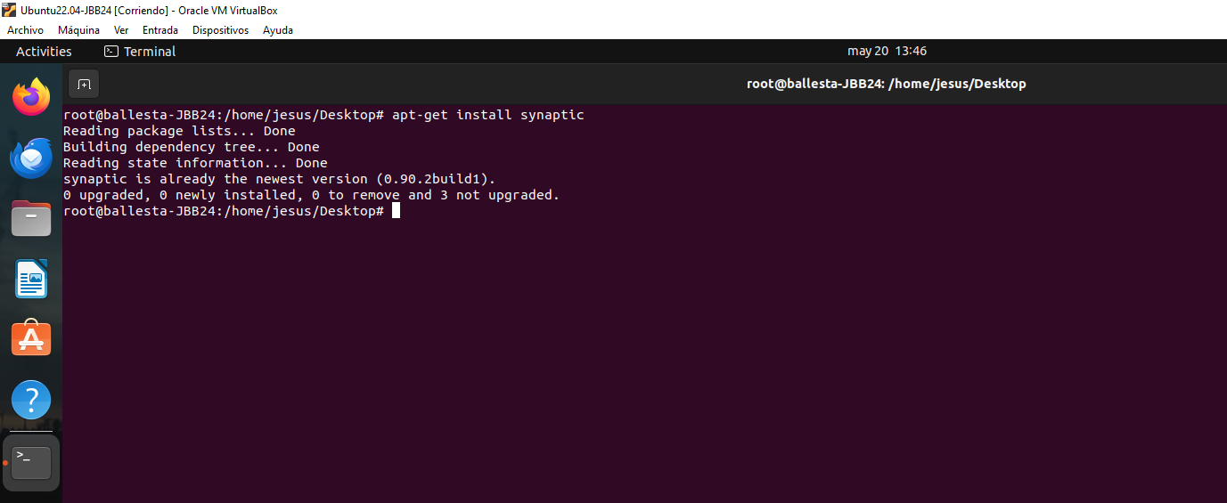
- By using Synaptic, install the text editor joe.
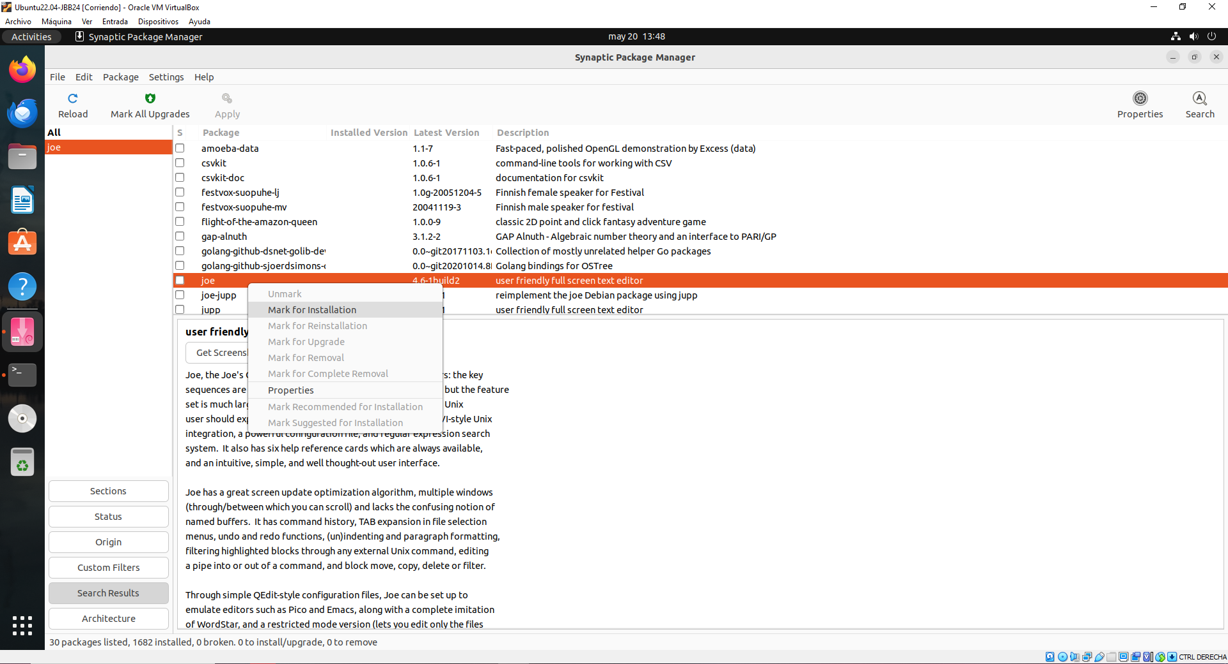

- Create a file on your desktop with LibreOffice Writer, named Writer-<initial>.odt with your full name.
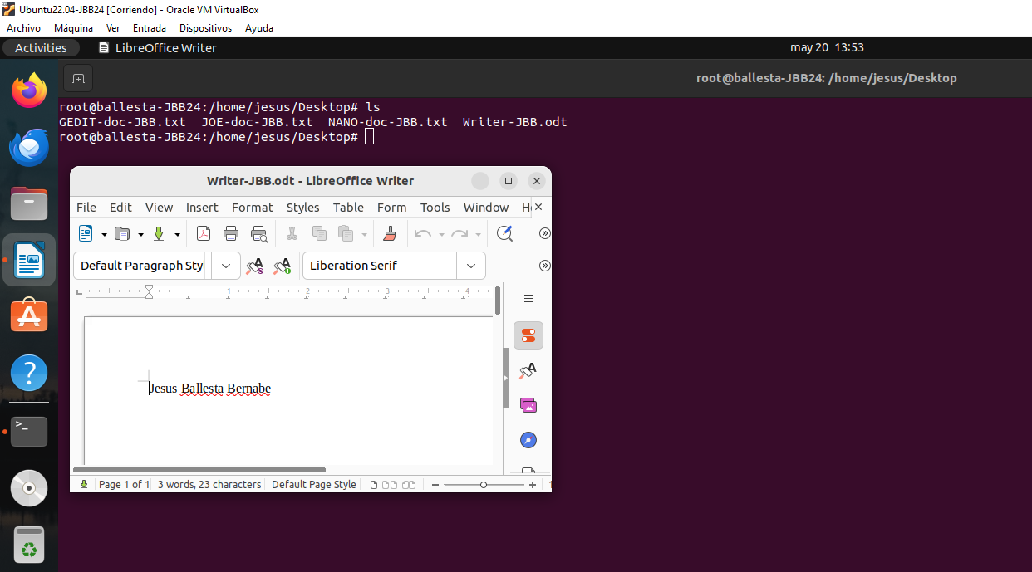
- Uninstall text editor joe by using Synaptic.
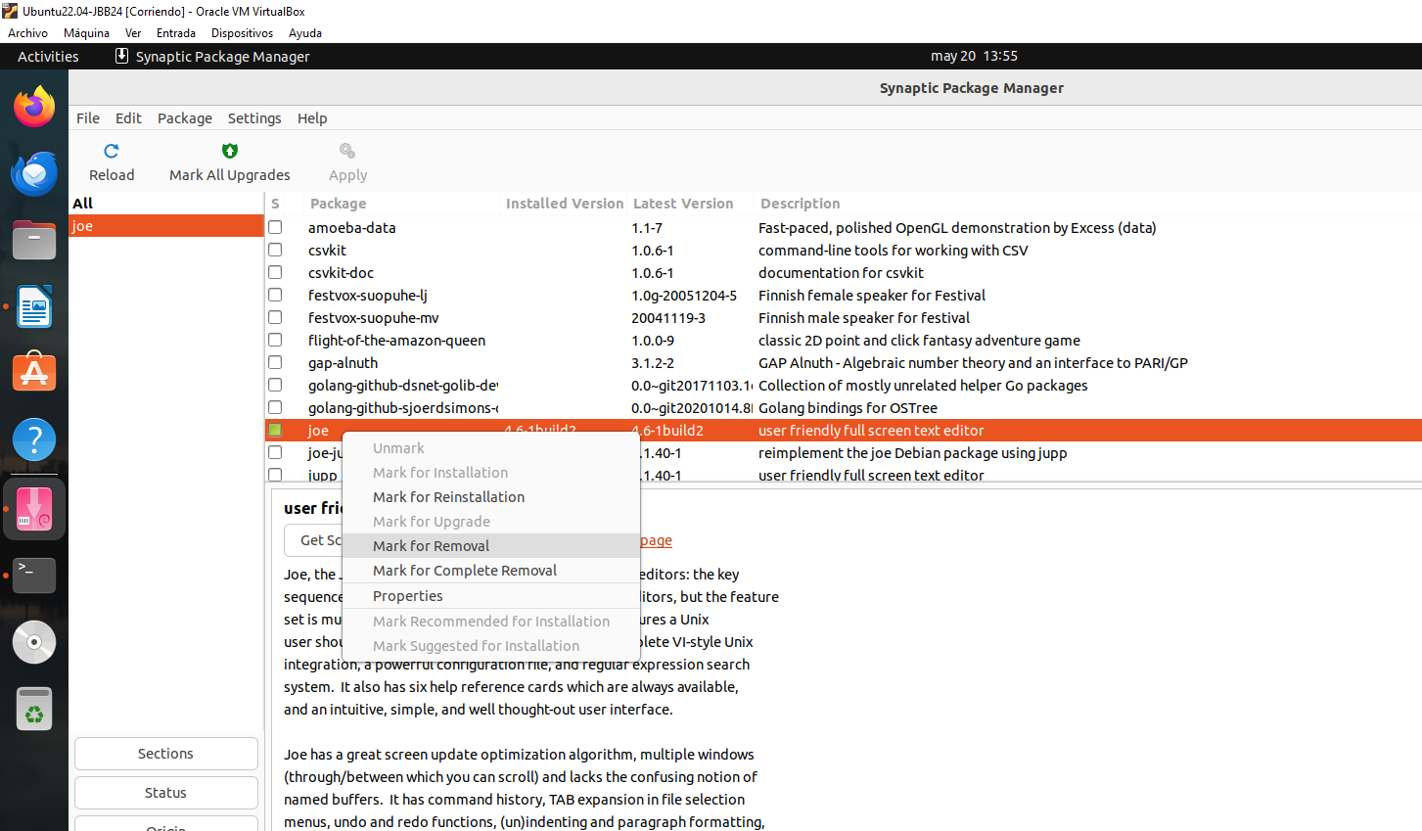
- Explain the directory structure of GNU/Linux systems, and the content of each system directory. [Answer].
- Run on a terminal the commands:
$ id
$ groups
$ pwd
$ hostnamctl
$ ip a
$ ps -aux
$ df -h
$ free -h
$ lscpu
$ date
$ ping <real computer IP>
$ sudo su
# su username_account

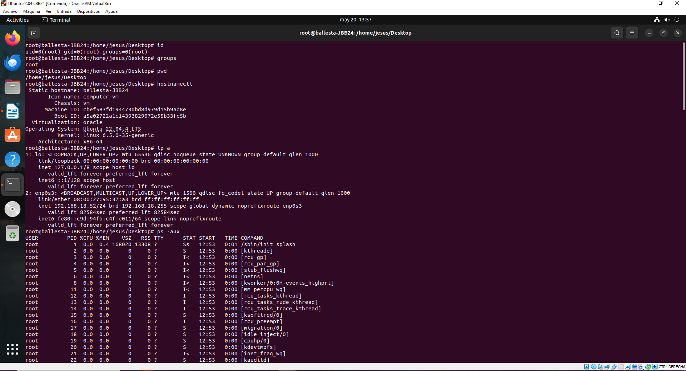

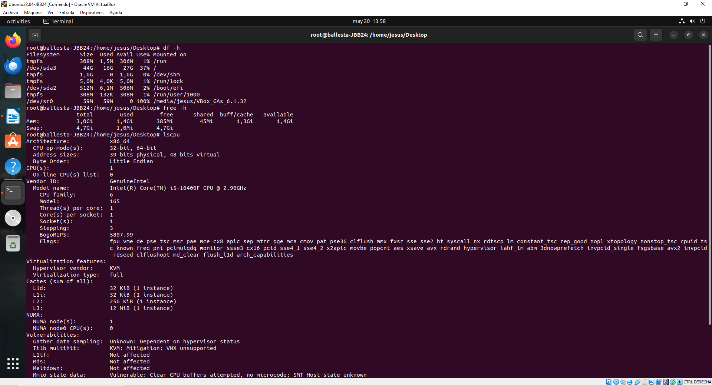

- Carry out a command to upgrade the system (not the distro) and show that it was successfully.
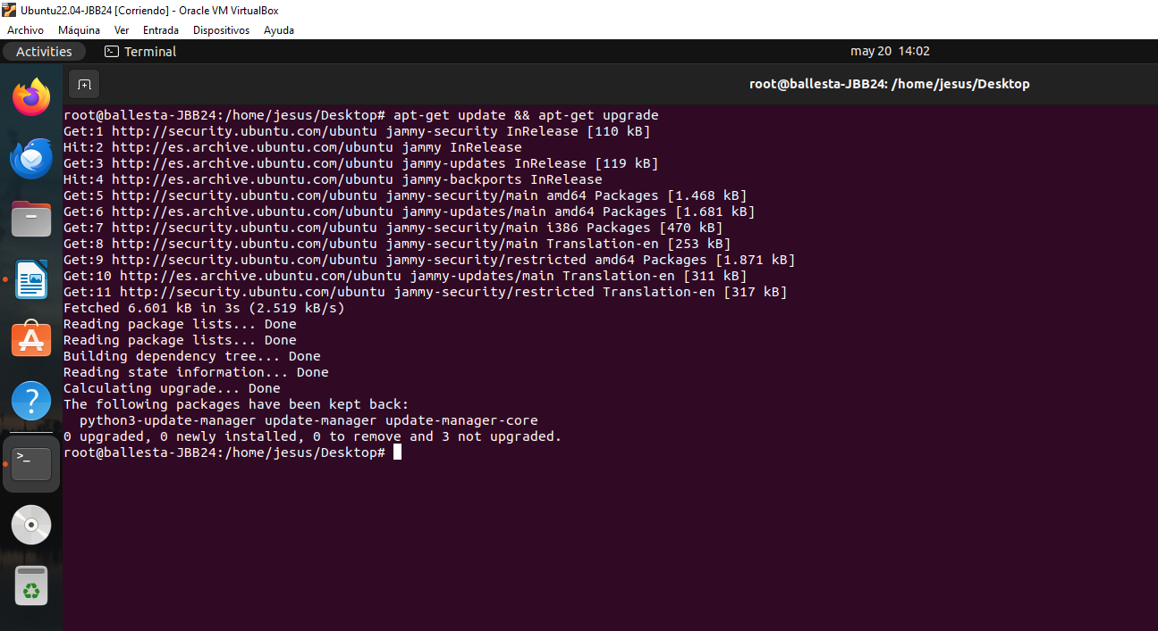

- Execute commands to troubleshoot packages (by using apt).
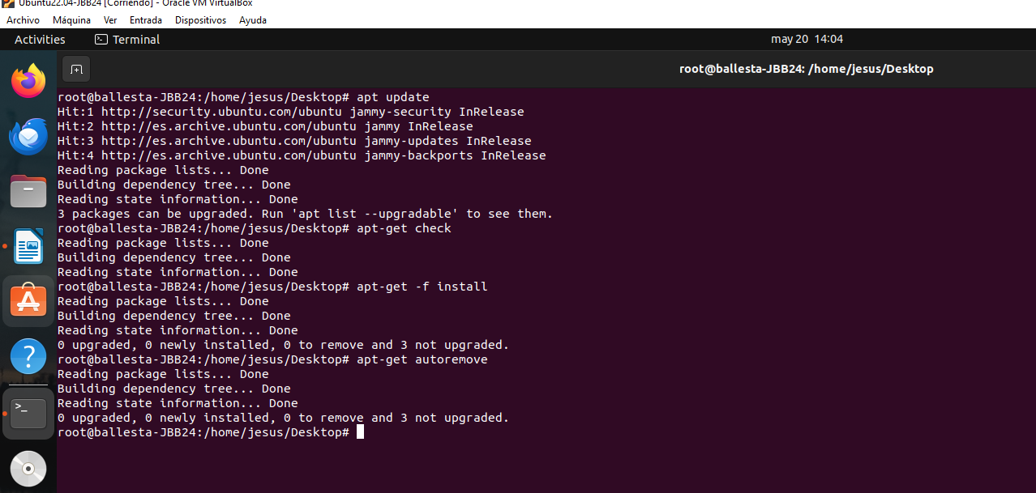

- Perform a command to troubleshoot deb packages (by using dpkg).
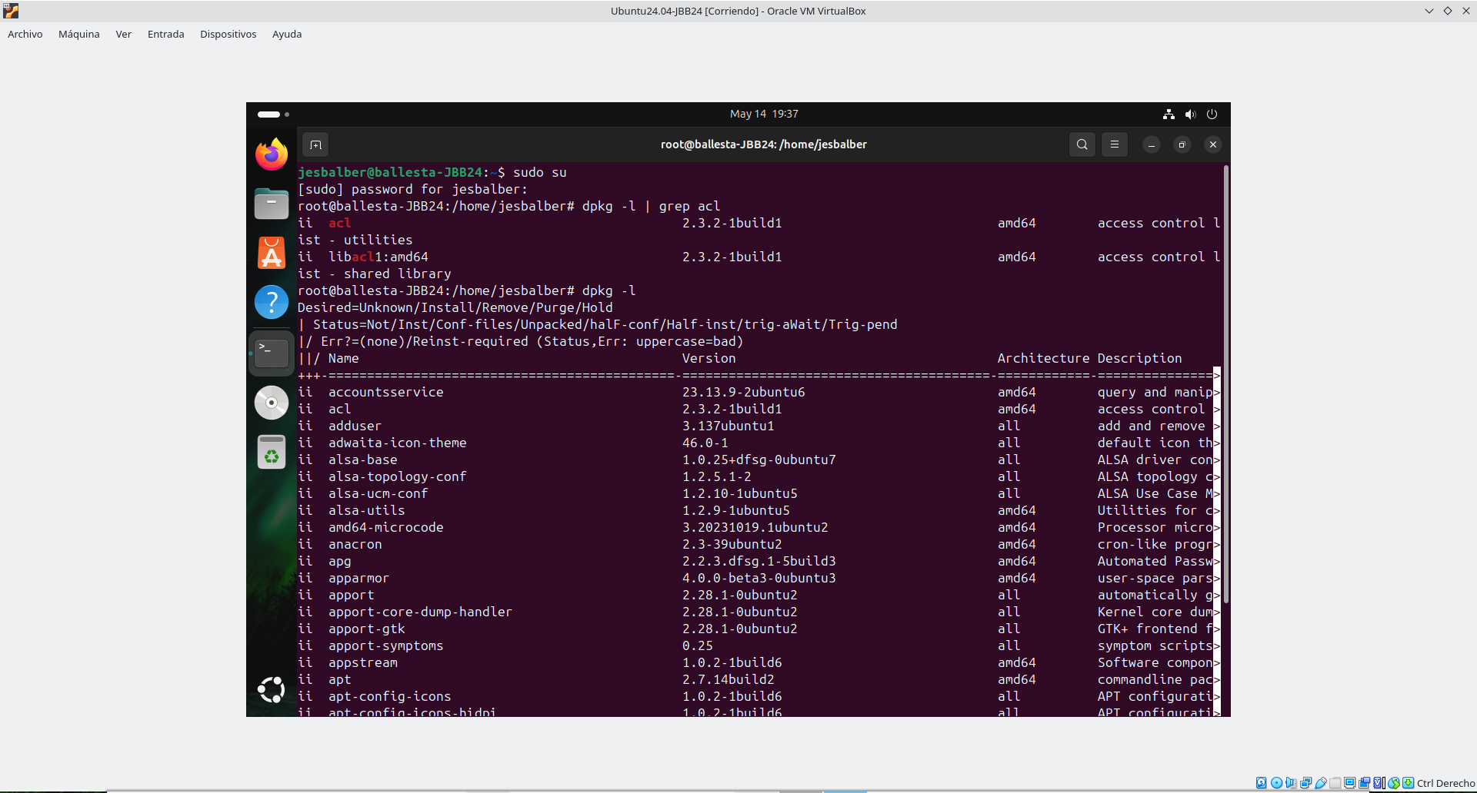
- Execute a command to clean obsolete packages and install script.
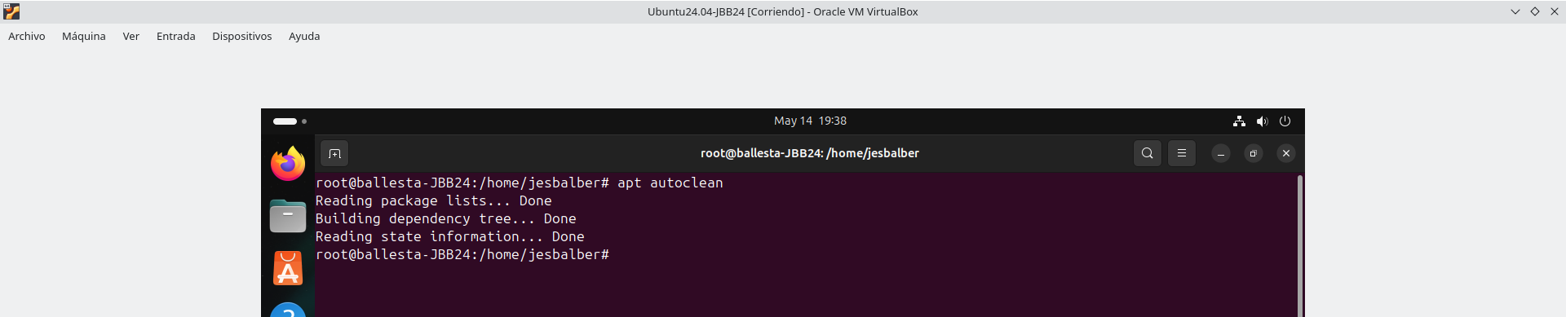
- Carry out a command to remove orphaned packages and purge them.
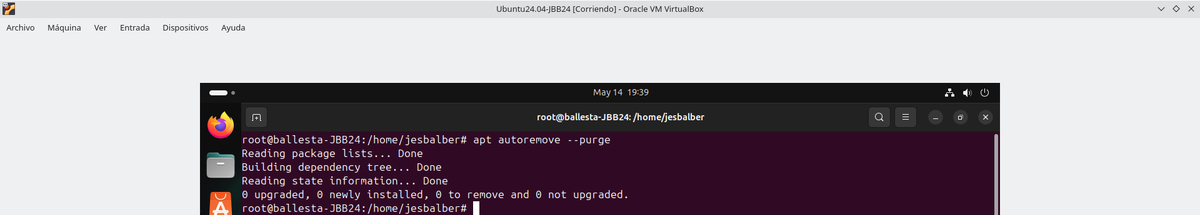

Webmin
- Install by using commands Webmin. (https://webmin.com/download/) [Take screenshots of the installation commands].
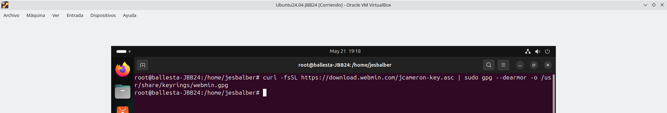

- Log in into Webmin, set up it in Spanish, and then restart it, to display everything in Spanish. [Screenshot].
- Sign in Webmin, set up it in English, and then restart it, to display everything in English. [Screenshot].
- Capture screens of Webmin, where the computer name and the time the system is up (uptime), the full network configuration (IP, NetMask, GW, DNSs), users (where student name appears), and running processes. [Screenshot].
- By using Webmin, install the module Samba Windows File Sharing. Create a folder on / called sf-<codId>. Set r/w permissions on the folder with command chmod 777 /sf-<codId> -R. Next, share the folder with Guest access and set read/write permissions. Access from your real computer and create a folder named: tsf-<codIdl>. [Screenshot].
- By using Webmin, access the terminal (shell) and run commands who -a, uptime, ip a and hostnamectl. [Screenshot].
- Change the Webmin theme, sign in again Webmin and take screenshot of the System information. [Screenshot].
Learning Outcomes and Assessment Criteria
Contents
1. Installation of Operating Systems:
- Functions of an operating system.
- Types of operating systems.
- Types of applications.
- Licenses and types of licenses.
- Boot managers.
- Virtual machines.
- Considerations prior to the installation of free and proprietary operating systems.
- Installation of operating systems. Requirements, versions and licenses.
- Installation/uninstallation of applications. Requirements, versions and licenses.
- Updating operating systems and applications.
- Operating system boot files.
- Device drivers.
- Documentation of installation processes.
Learning outcomes | Evaluation criteria
LR 2. Installs operating systems by planning the process and interpreting technical documentation. | a) The functional elements of a computer system have been identified.  b) The characteristics, functions and architecture of an operating system have been analyzed.  c) Operating systems have been compared on the basis of their requirements, characteristics, fields of application and licenses of use.  d) Different operating systems have been installed.  e) System upgrade and recovery techniques have been applied.  f) Virtual machines have been used to install and test operating systems.  g) The processes carried out have been documented.

